Terraform -04

1). Watch Terraform-04 video.
Watched
2). Execute the script shown in the video.

Restricting the Provider
By using the which version of terraform we are using
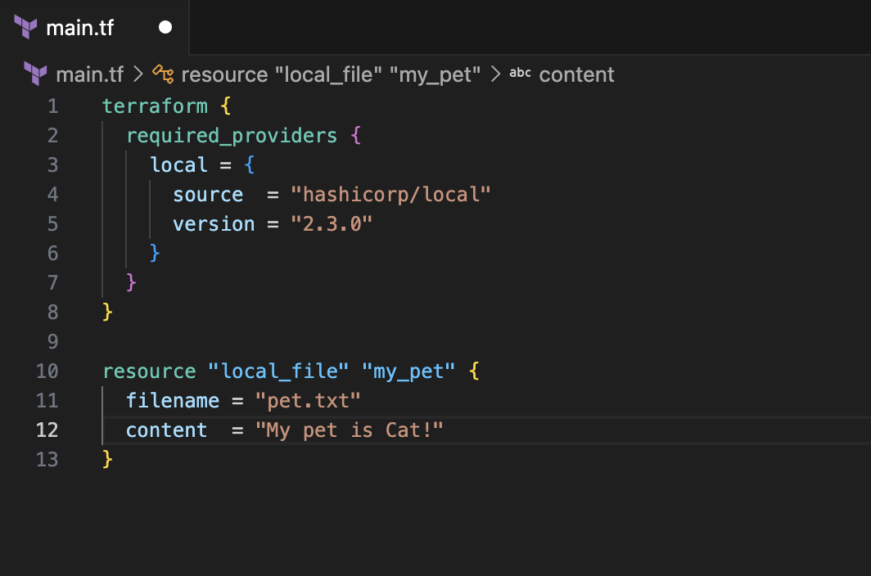
Now lets run this
Its shows version 2.3.0 as we are giving it specific
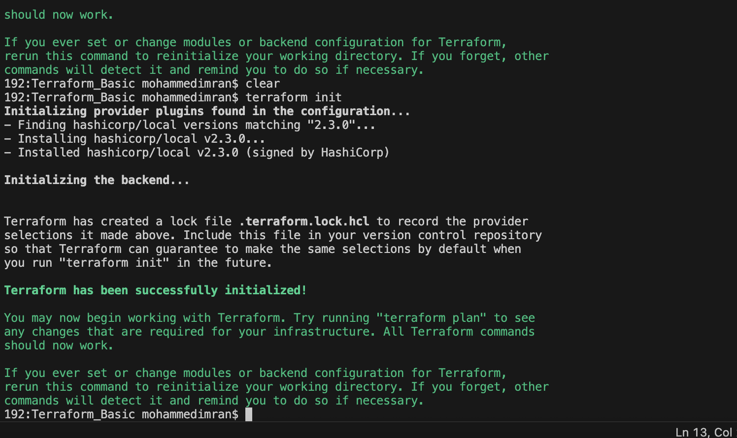
If incase if we want to download without providing the specific version it will download the latest version

Lets check

In the below image my main.tf doesn't consist any specific version of terraform so its downloading the latest when we do terraform init

By using specific versions of providers we can restrict the providers. That's how we can define it in our configuration file.
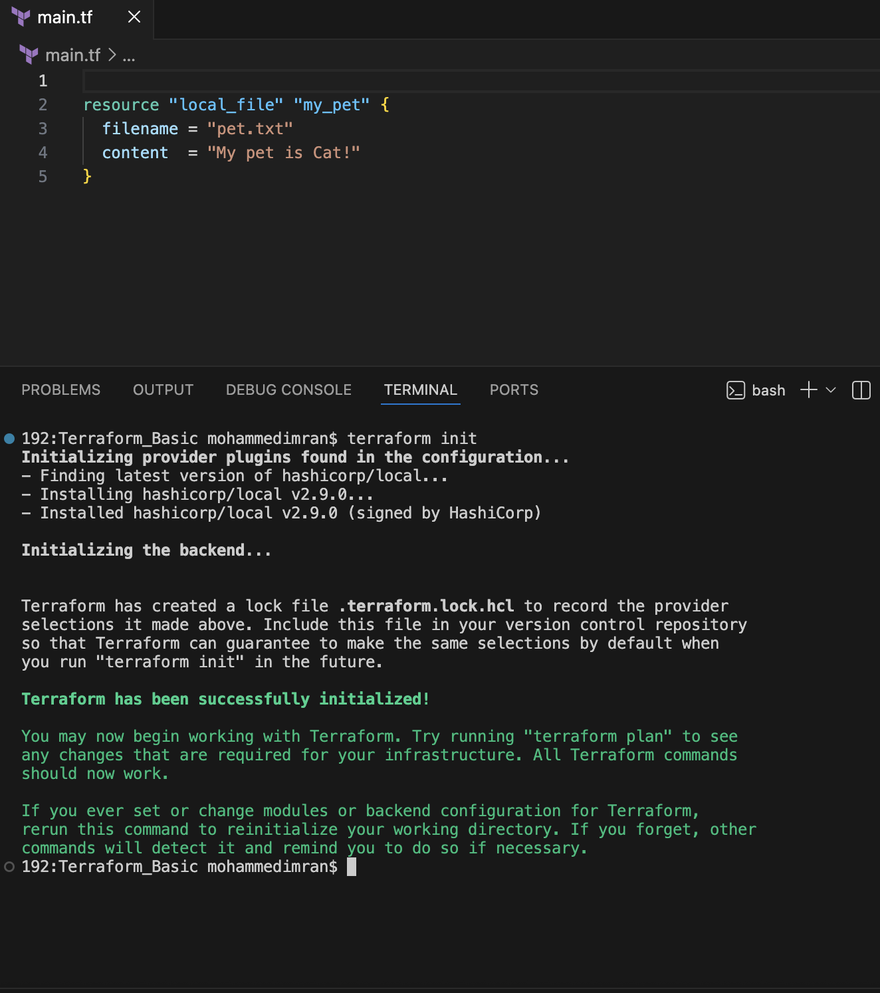

As in the above pics we have seen to restrict. Now lets see how we can change/upgrade to different version
In the below main.tf file i have give code of 2.3.0 and executed terraform init as it was a different version it didn’t allow me to do.
For upgrading
terraform init -upgrade
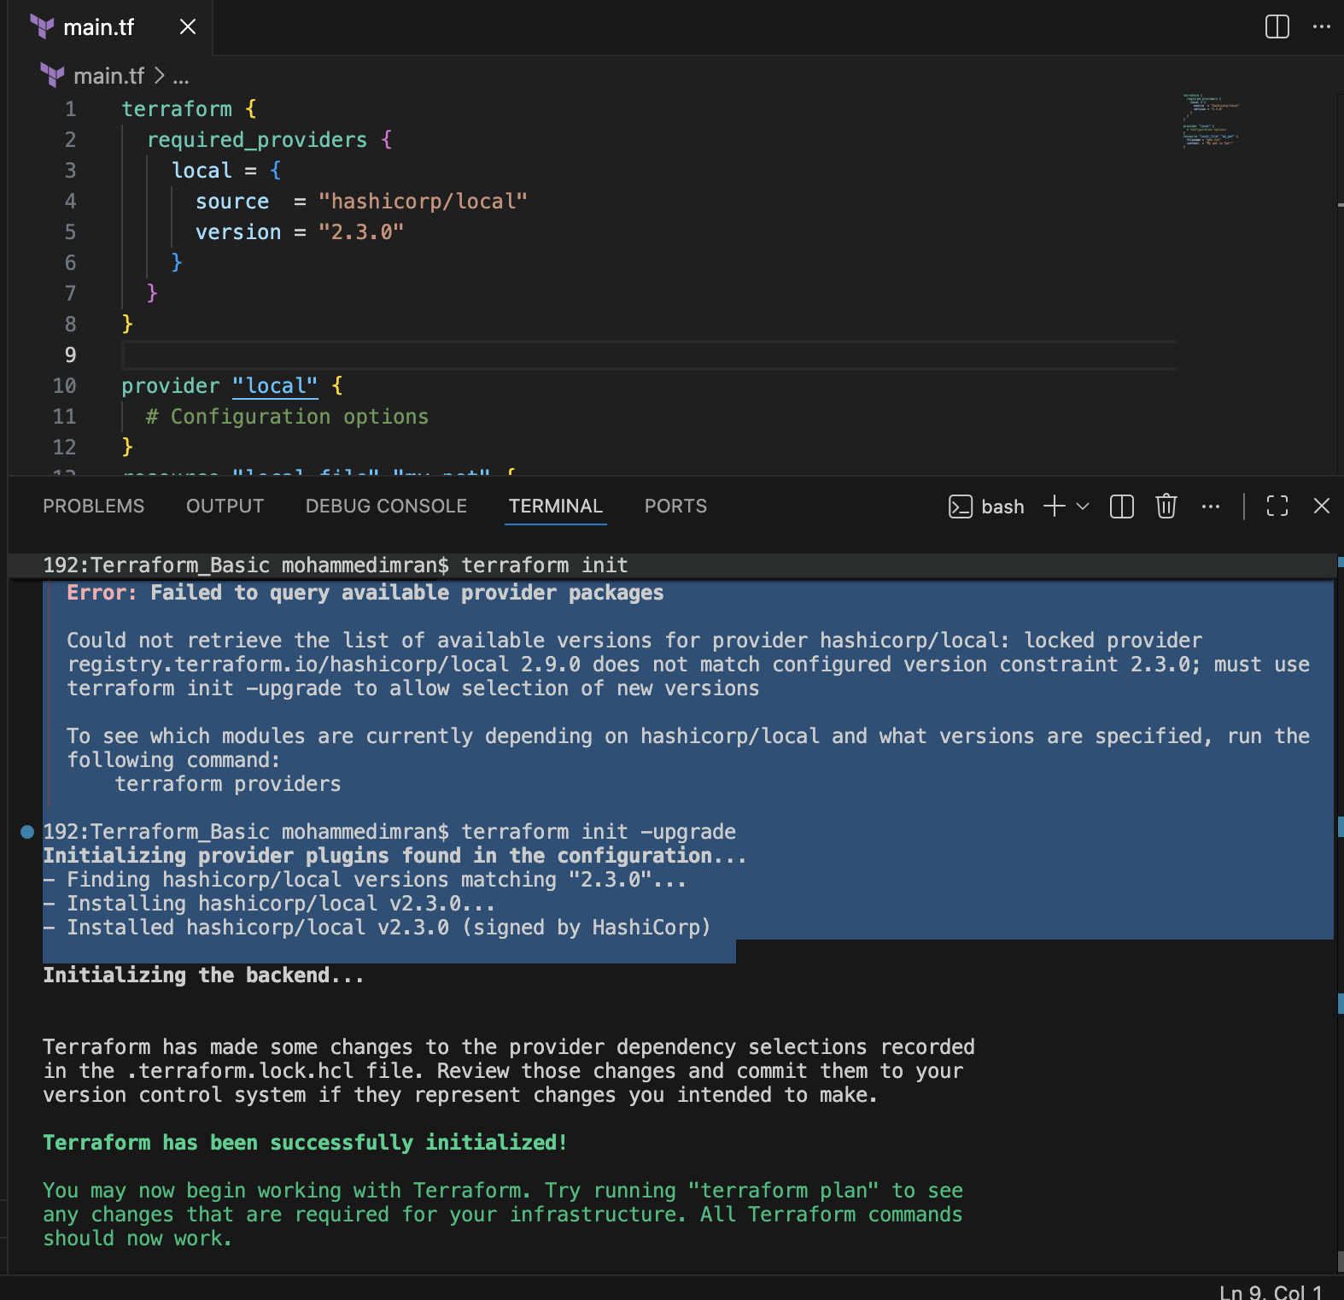

We can two versions of terraform has been in our .terraform directory
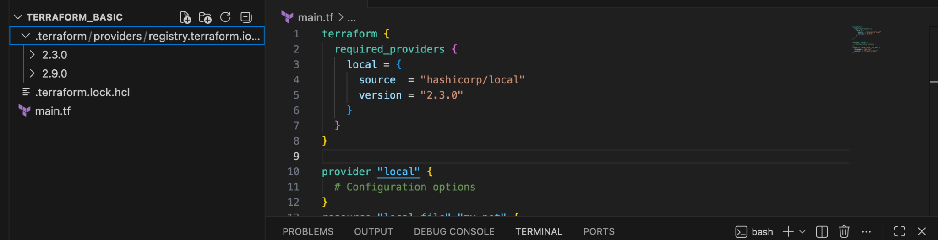

DATA BLOCK⇒ To read the content of the file.
So I created a file called dogs.txt
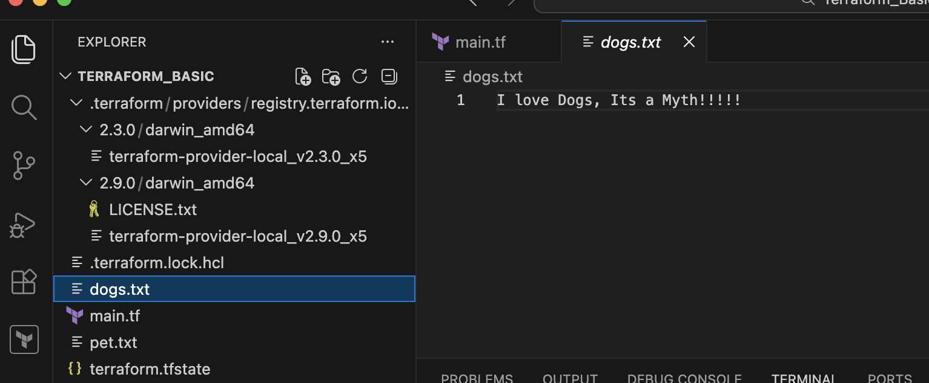
And now I’m asking it to read the content from my dogs.txt file to pets.txt
My main.tf
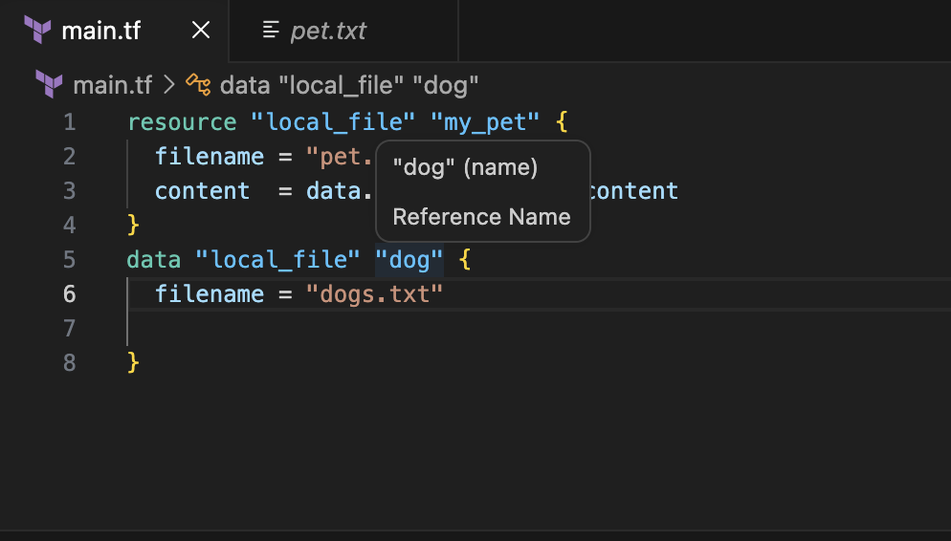
Once terraform apply
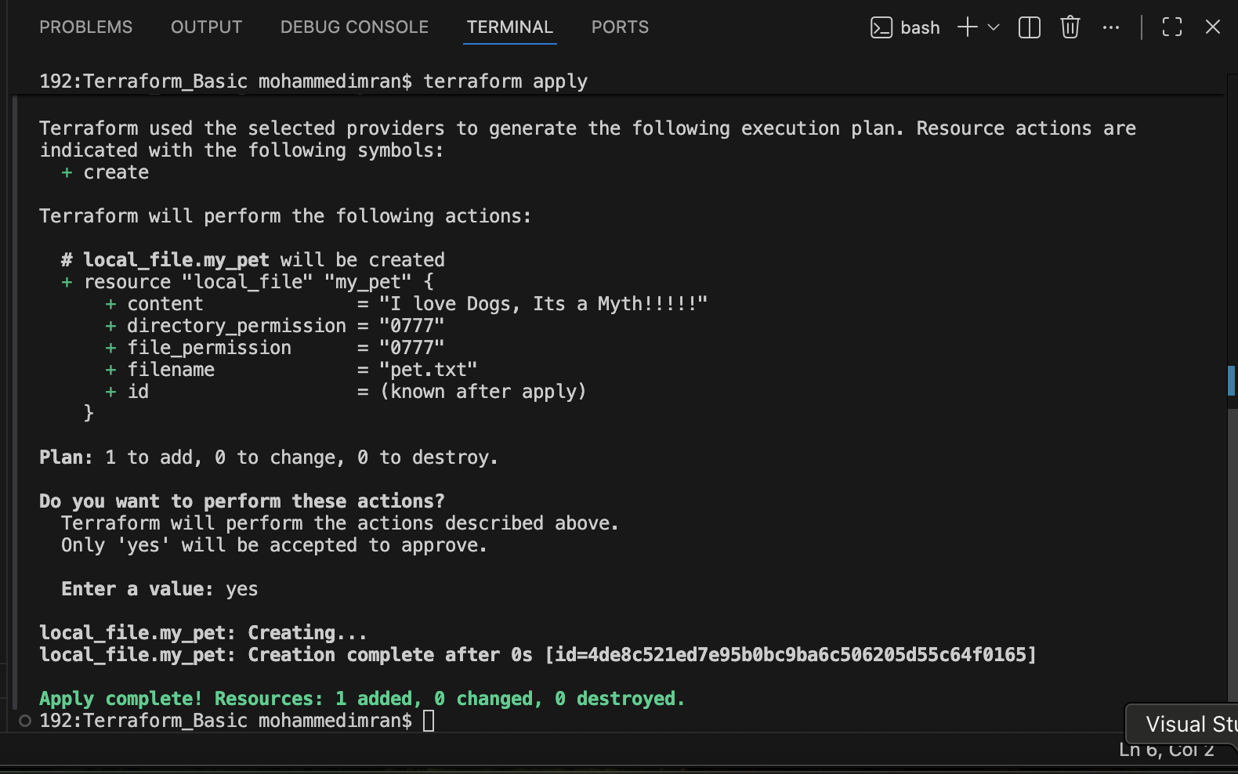
Lets check the output
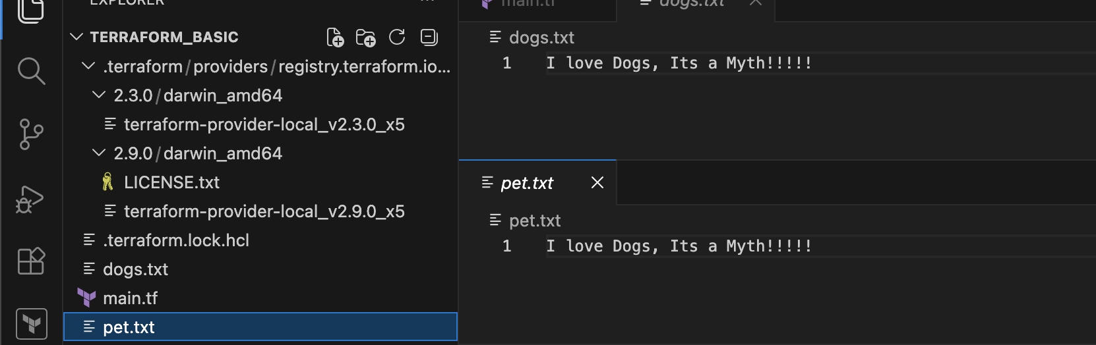

META ARGUMENTS:
Meta arguments are used if we want to create multiple resources.
- Depends on
- Lifecycle rules
- create_before_destroy
- prevent_destroy
- ignore_changes
- Count
- For - each
COUNT⇒ If we want to create multiple files at a time we can use count.
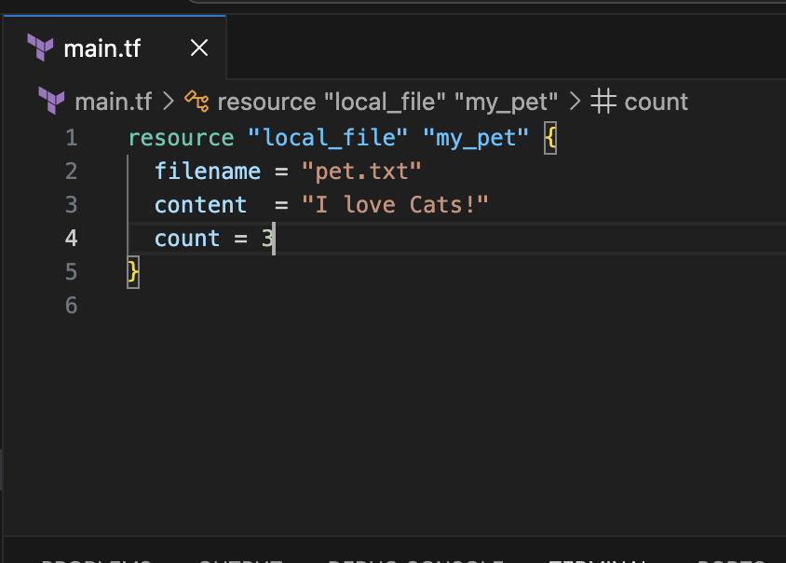
terraform apply
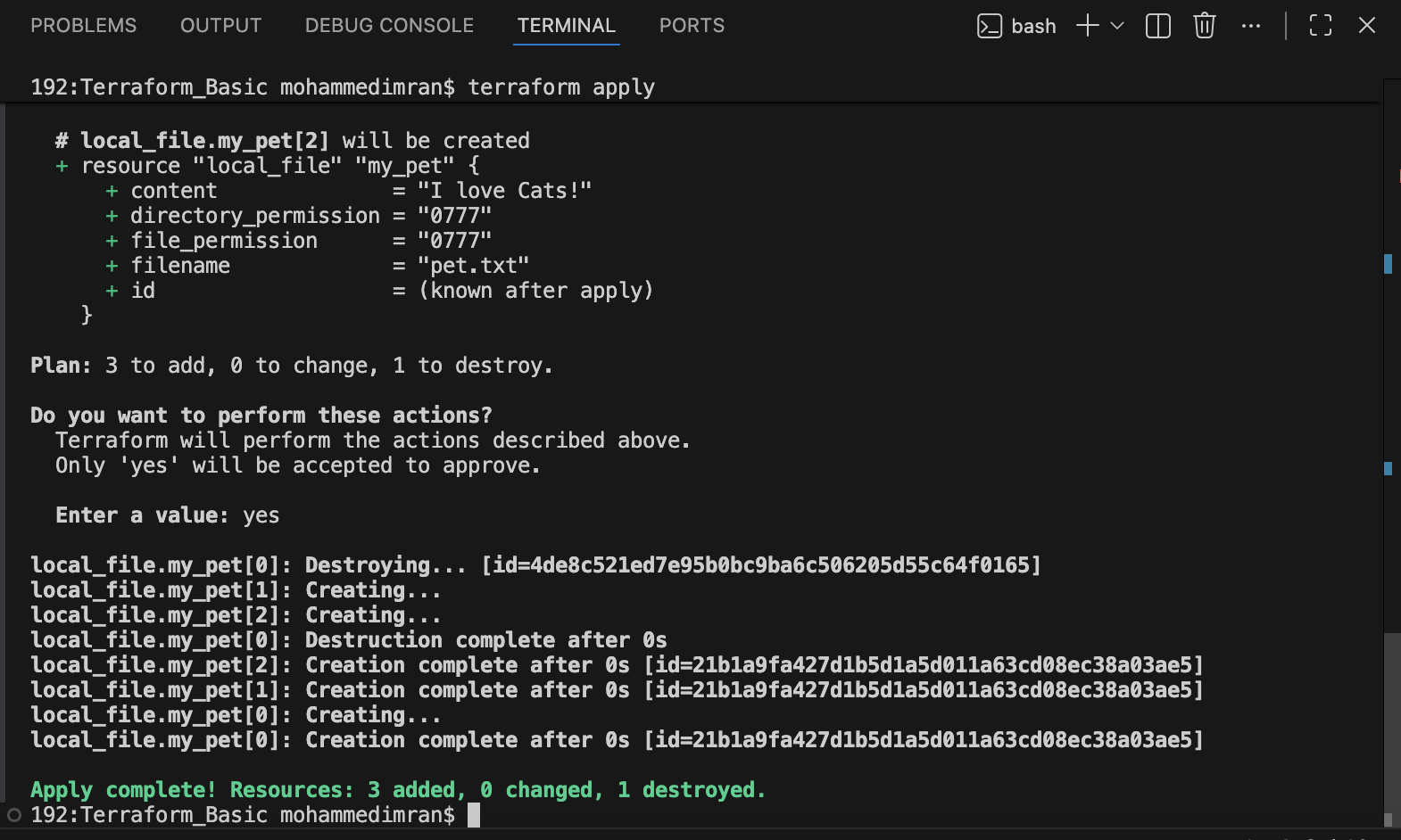
It says created, lets see if it has been created or not
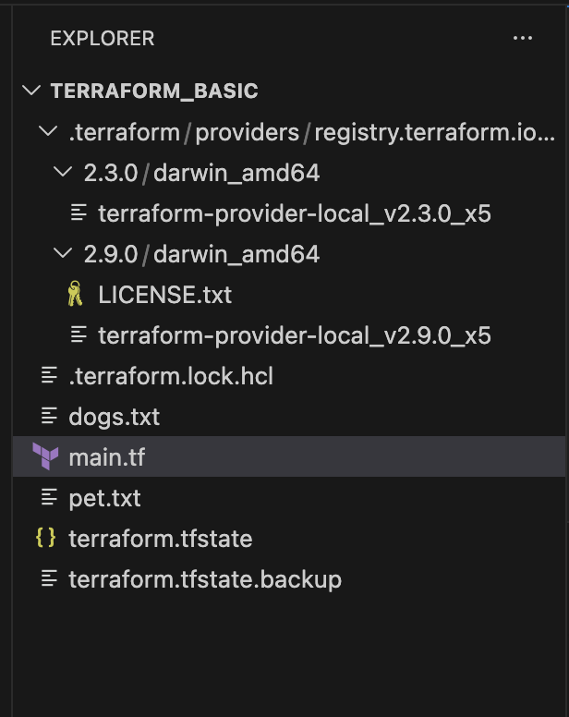
No extra file has been created, the reason is its been overwritten. So for these cases we need to create a variable file and need to give the count index in the main.tf file then only multiple files can be generated.
Let's see how it can be done now.
First lets create a variable.tf file and give the details of file names what we want to create and made the necessary changes in main.tf file too
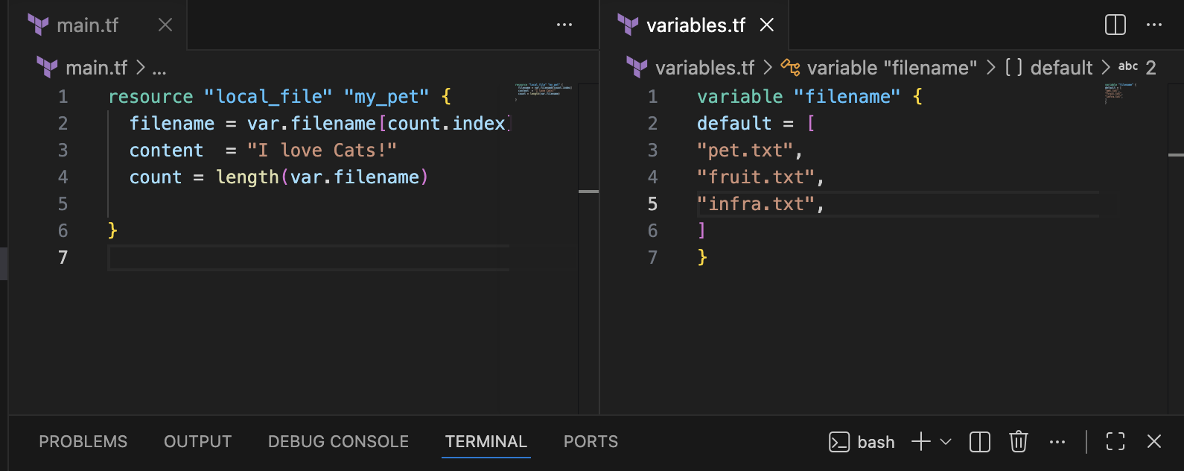
Lets execute terraform apply ⇒ERROR
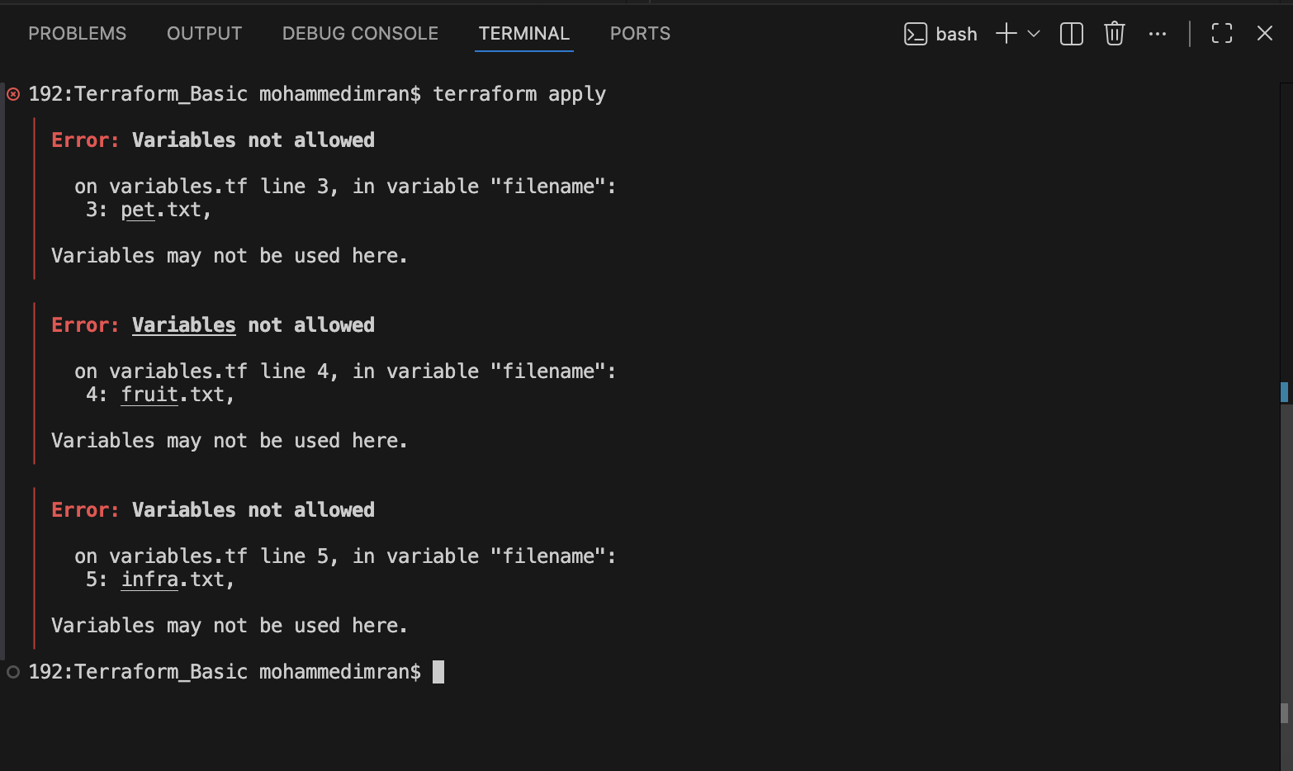
Lets remove the previous infra whatever we create and and try
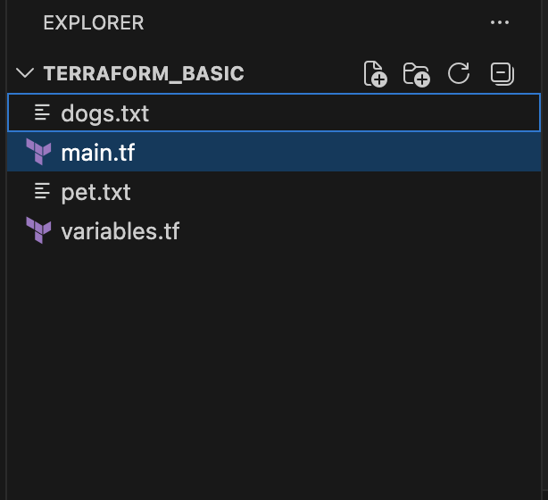
Now lets execute terraform init and terraform apply
terraform init
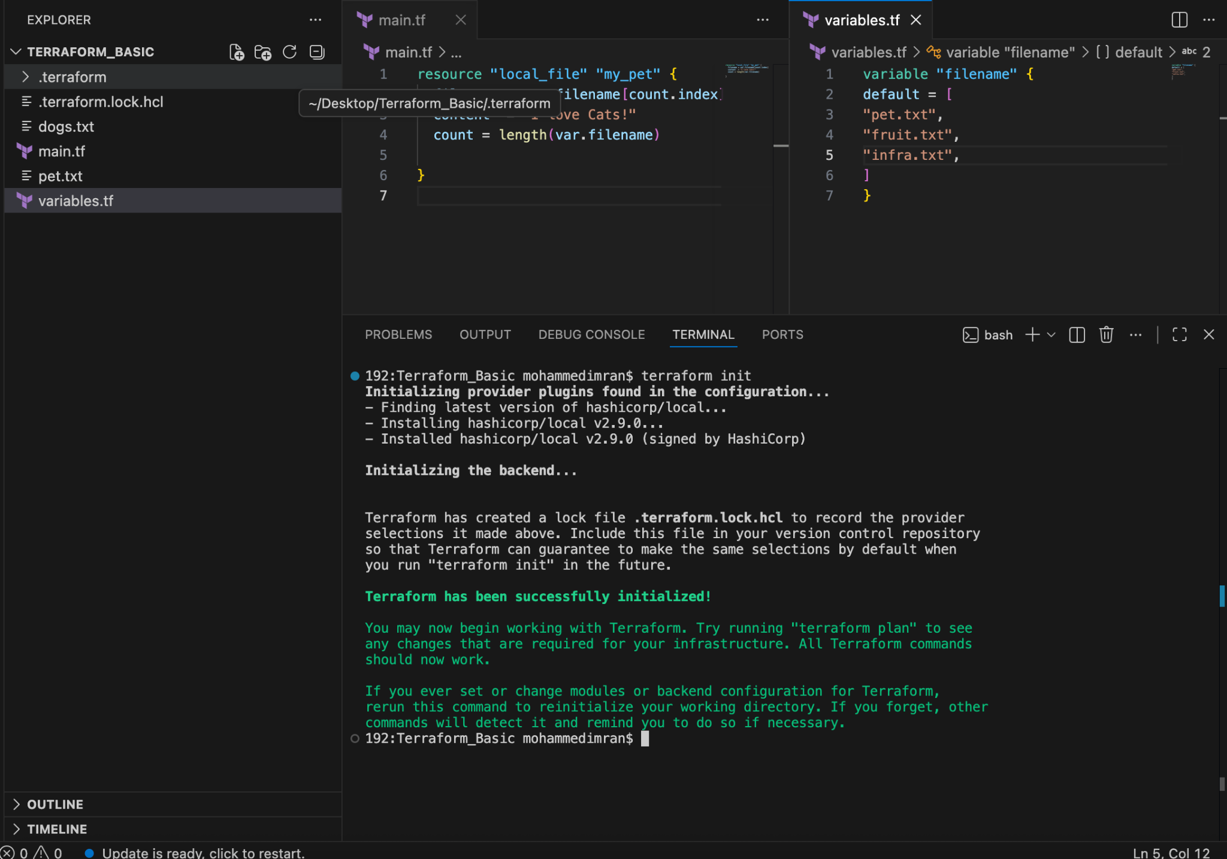
terraform apply
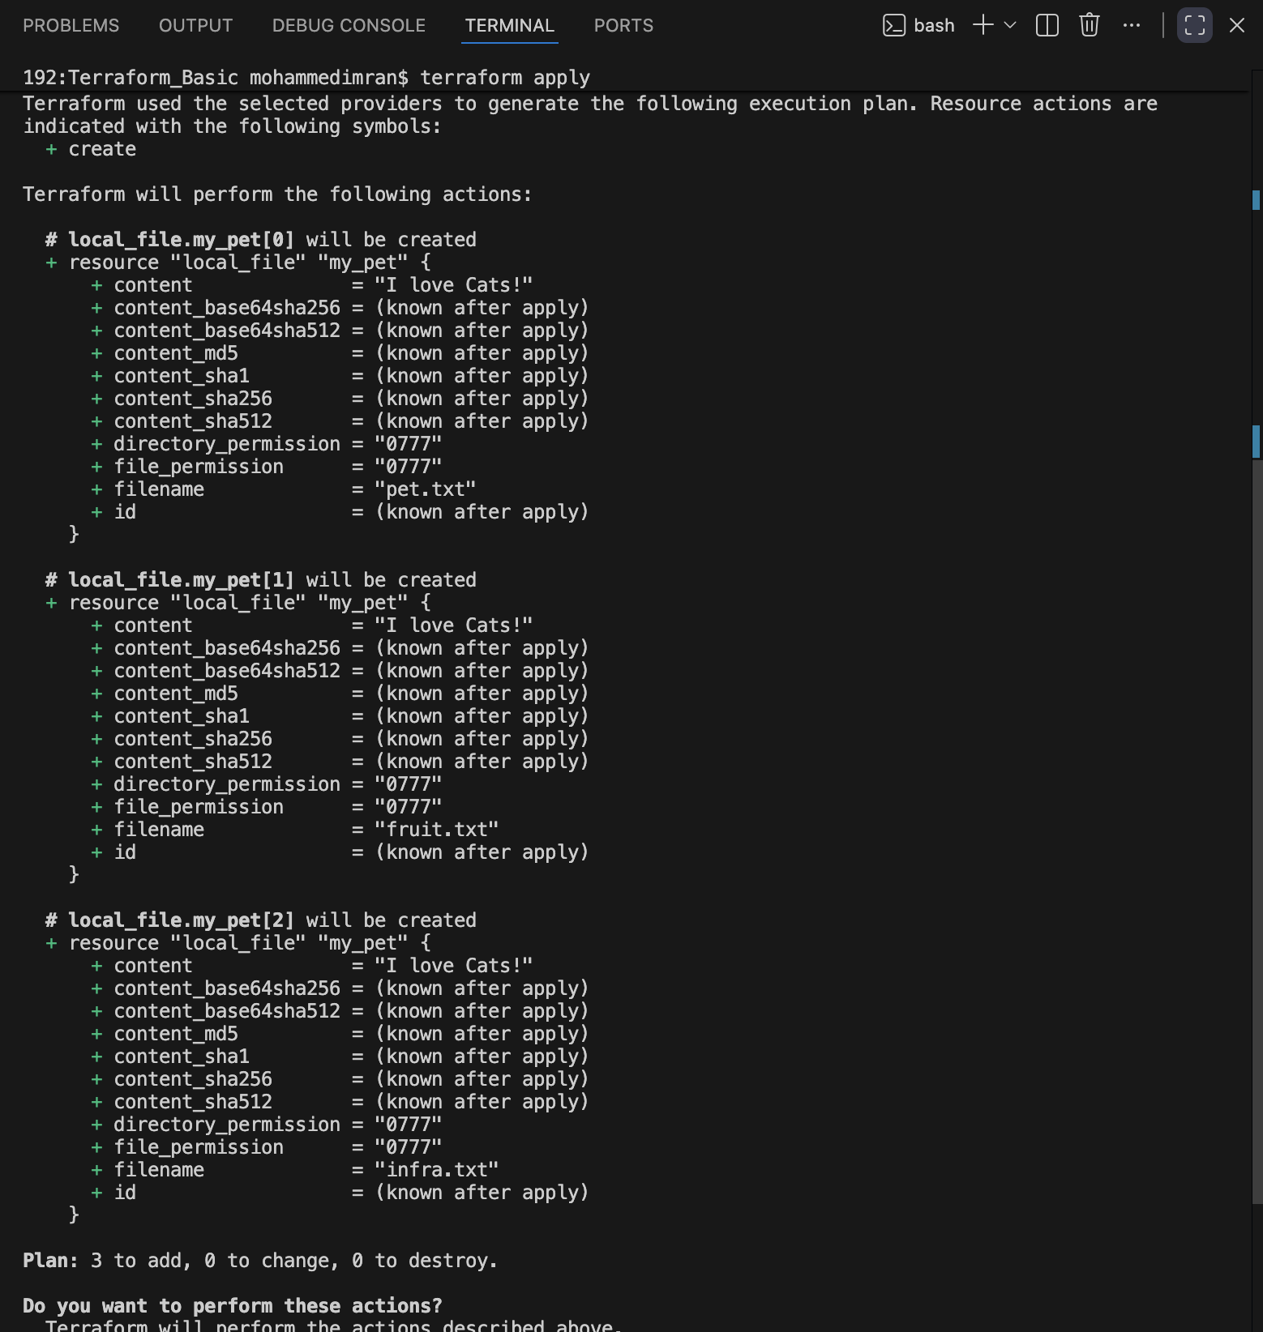
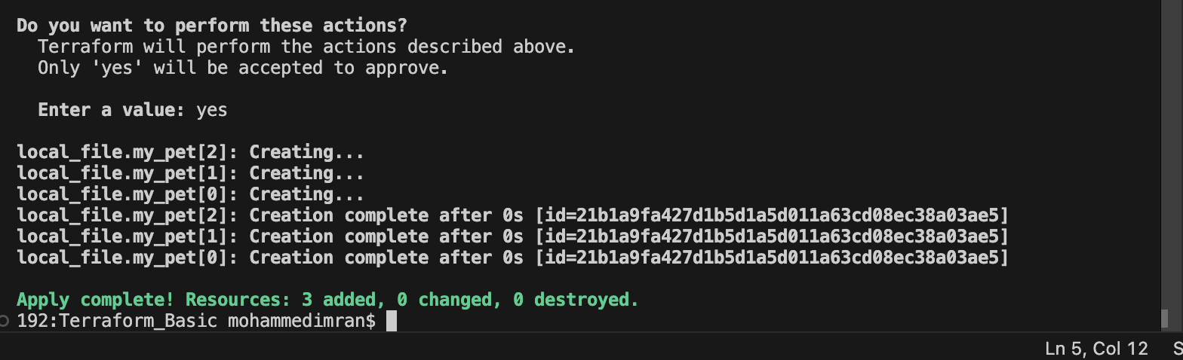
3-files have been created ⇒ USING COUNT
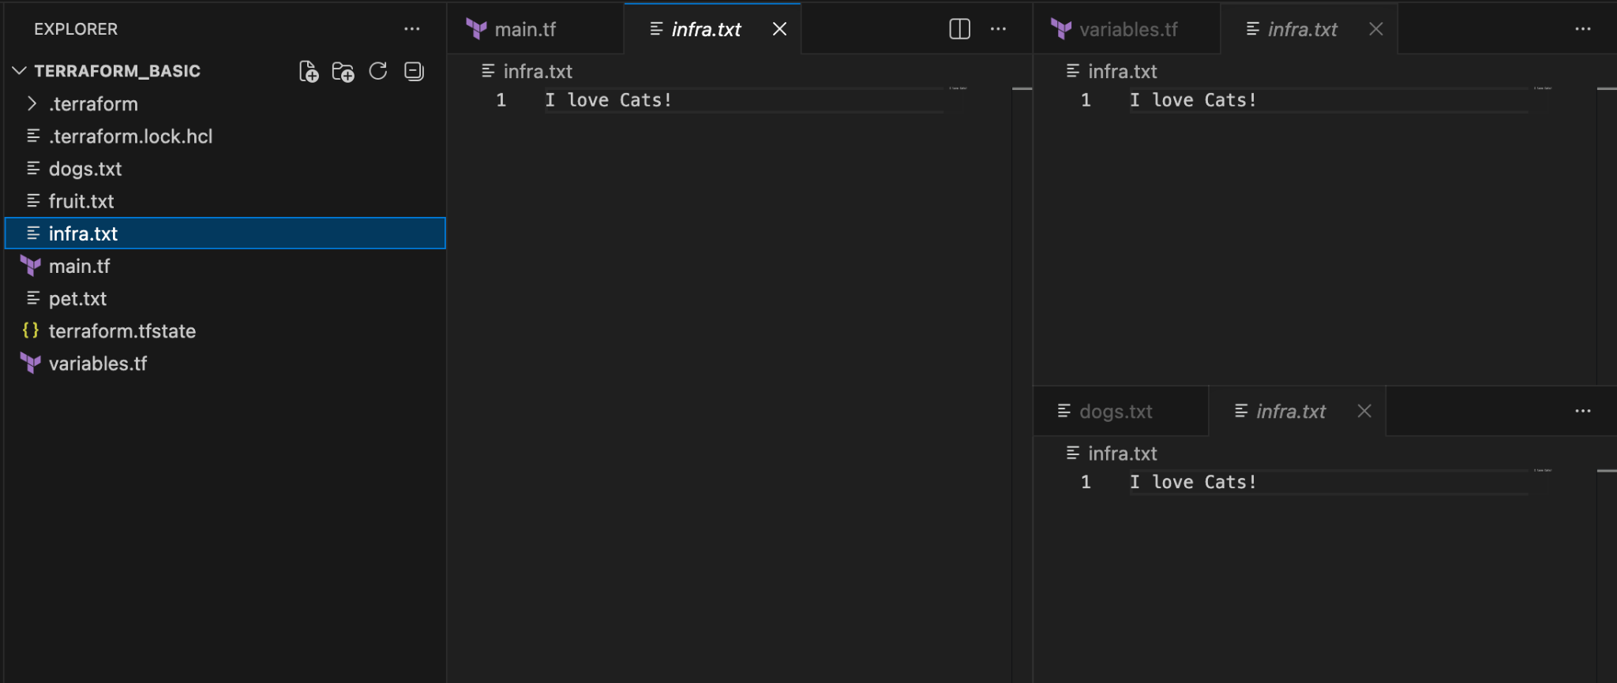
COUNT ⇒VARIABLE TYPE (LIST)

FOR-EACH ⇒ For creating multiple files with different attributes.

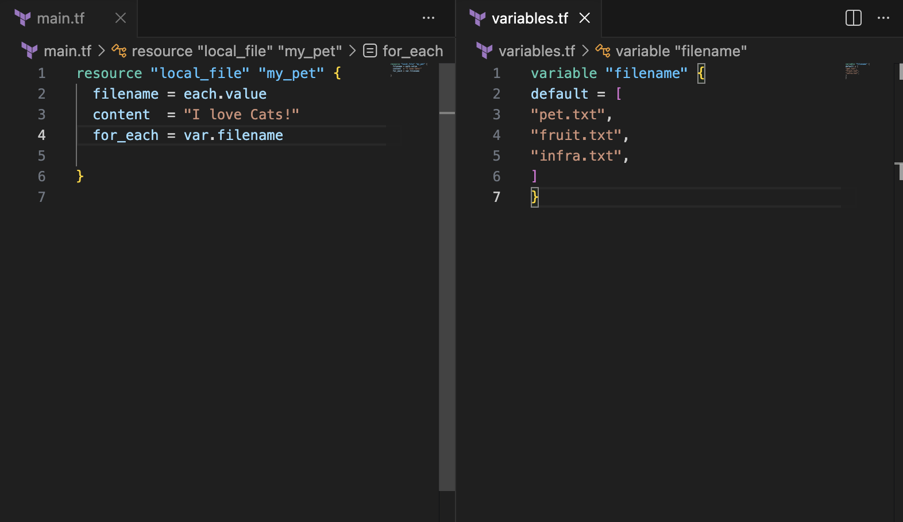
terraform apply
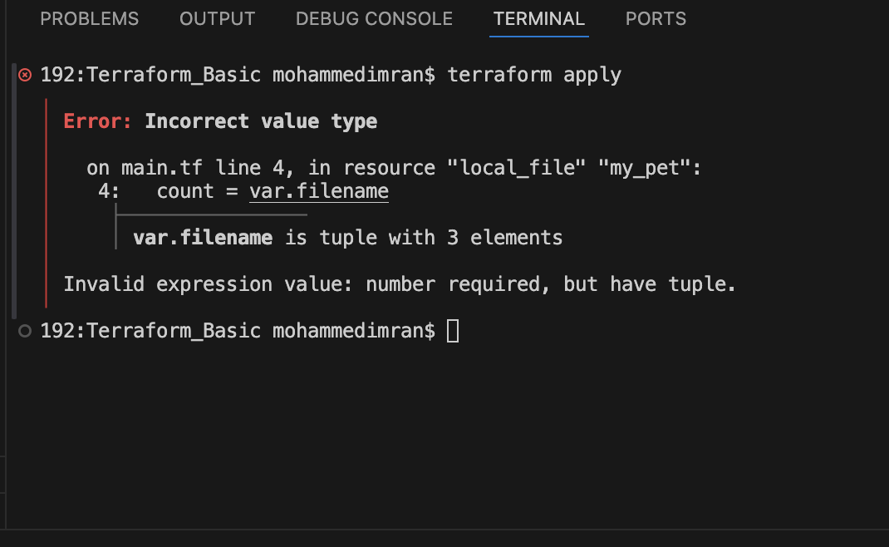
ERROR REASON:
For-Each uses different variable style it uses MAP.
So, here we can do by using two different methods like
- In main.tf we can change for_each = toset(var.filename)
- In variables.tf we can use type =set(String)
Both scenarios will work
First Scenario
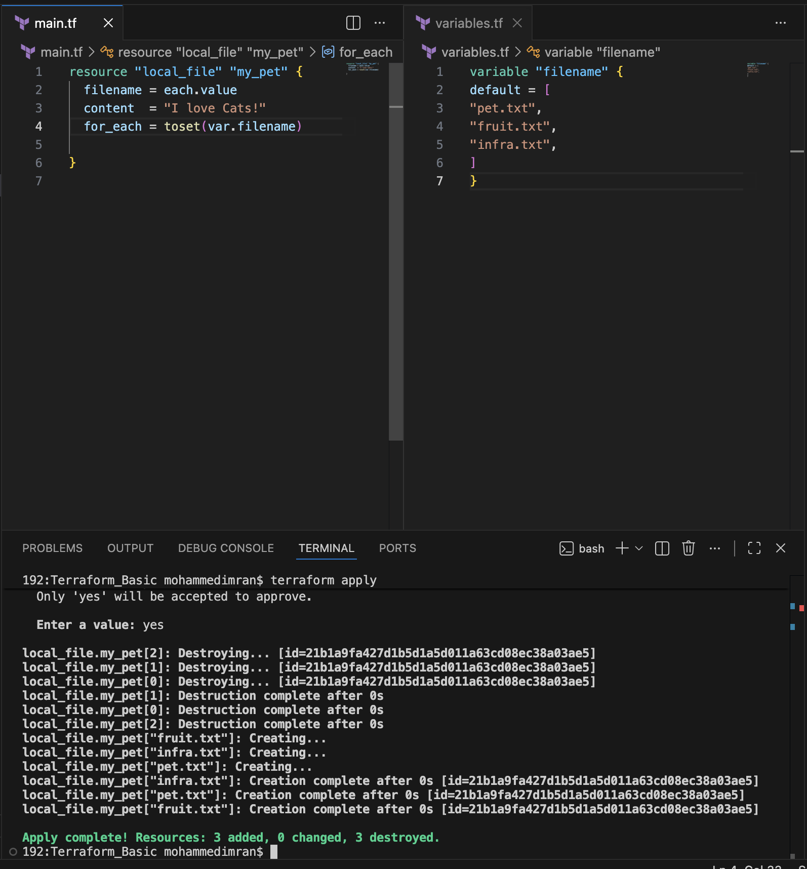
Second Scenario
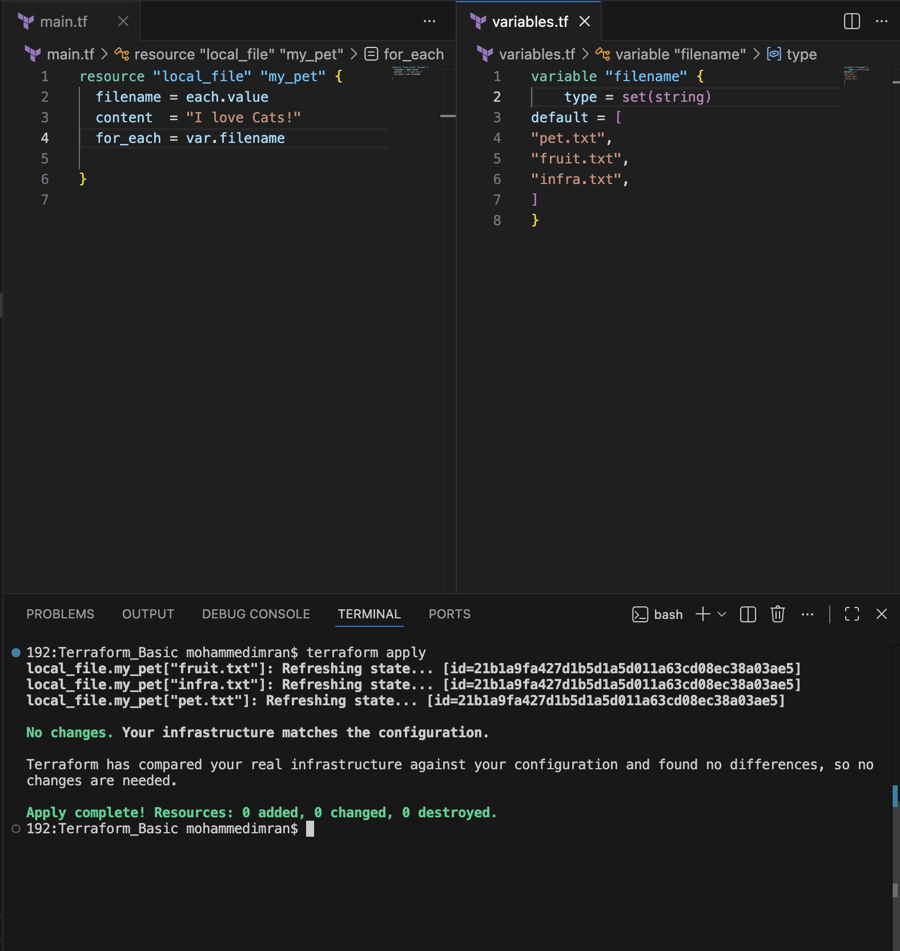

Lets create AWS services using terraform ⇒ Need to configure AWS access ID and password ⇒ without hardcoding in the main.tf file we can do it in cli using aws configure
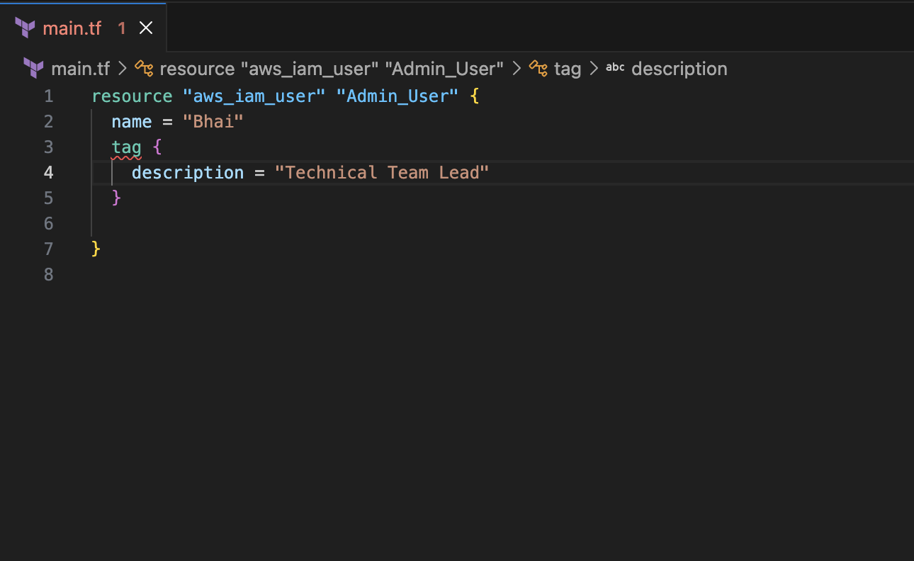
First lets terraform init
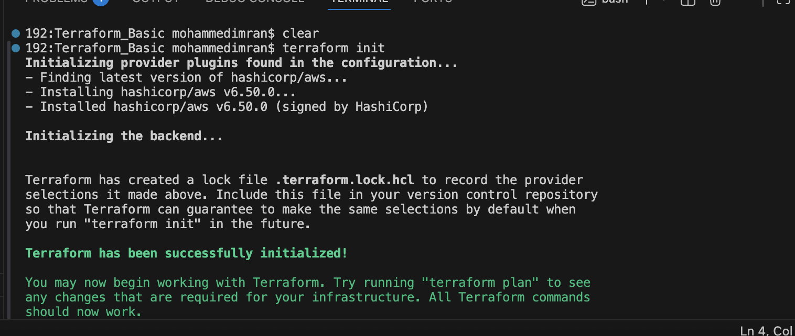
My resource block code is to create a IAM USER in AWS
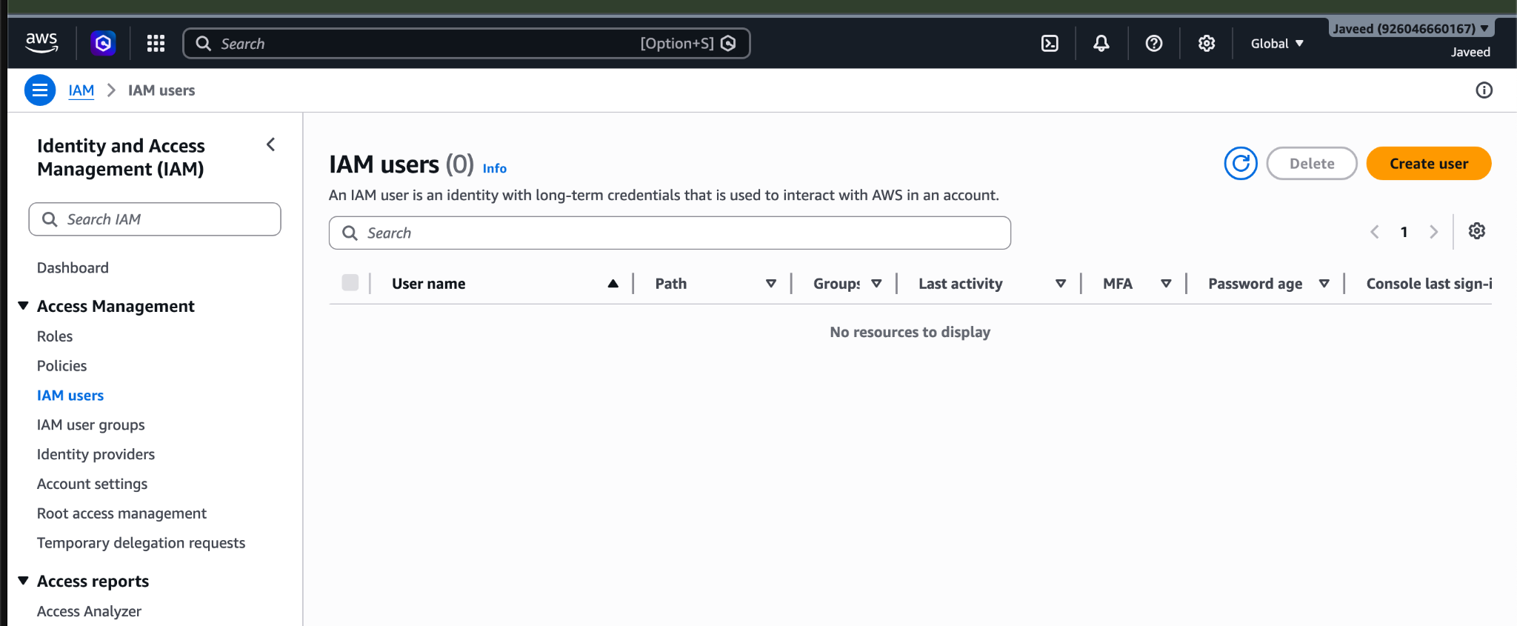
Lets see by executing terraform apply its creating or not
Got Error
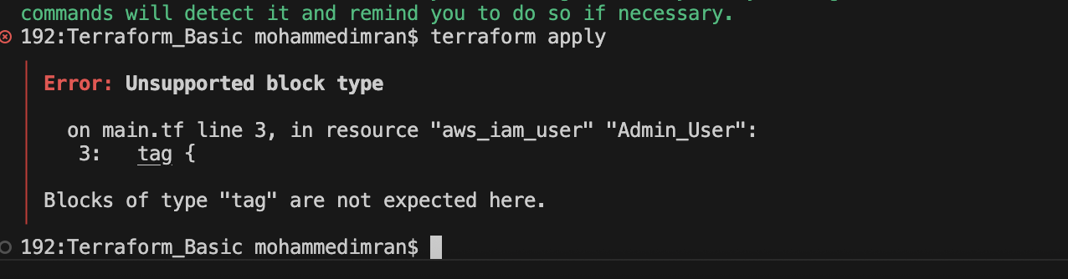
Reason didnt add “s” for tag ⇒tags
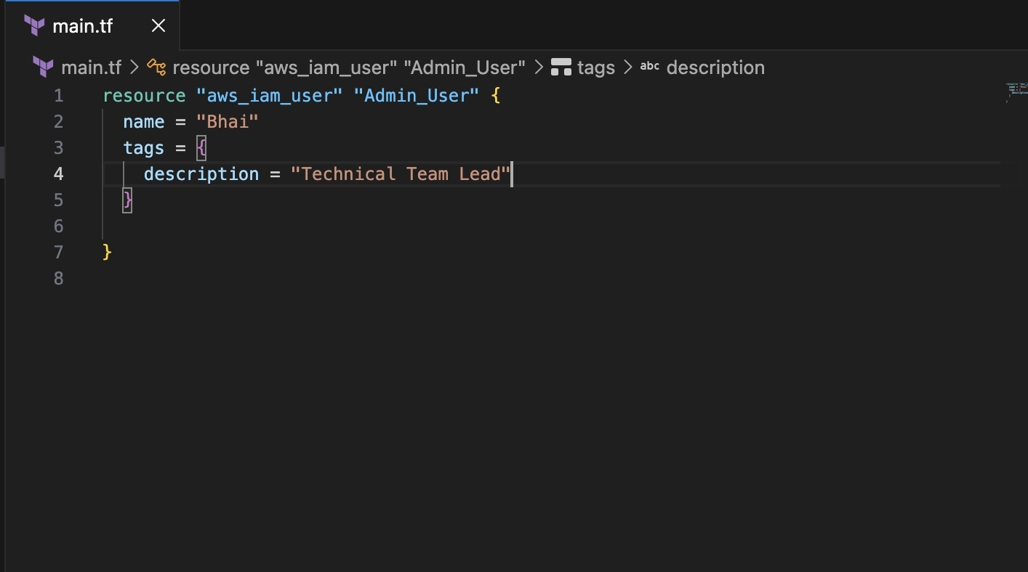
Its says it has been created
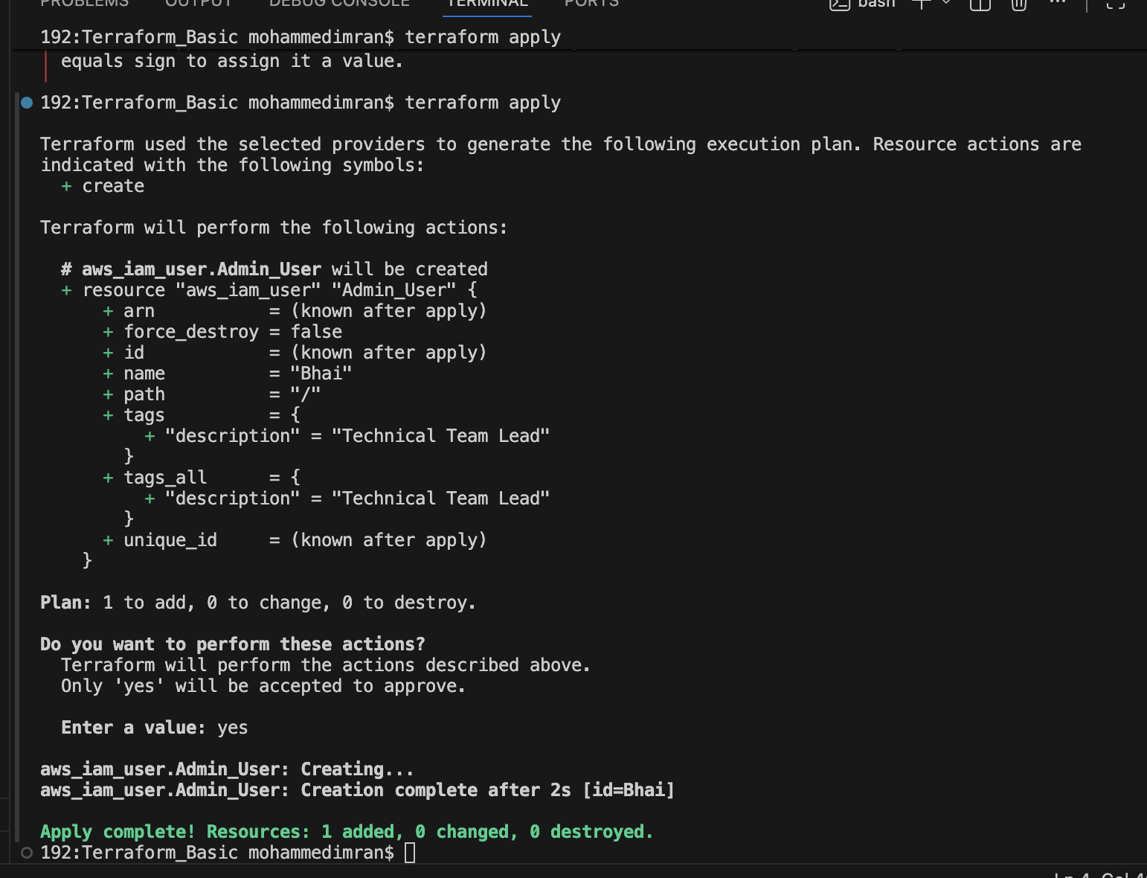
Lets check in AWS
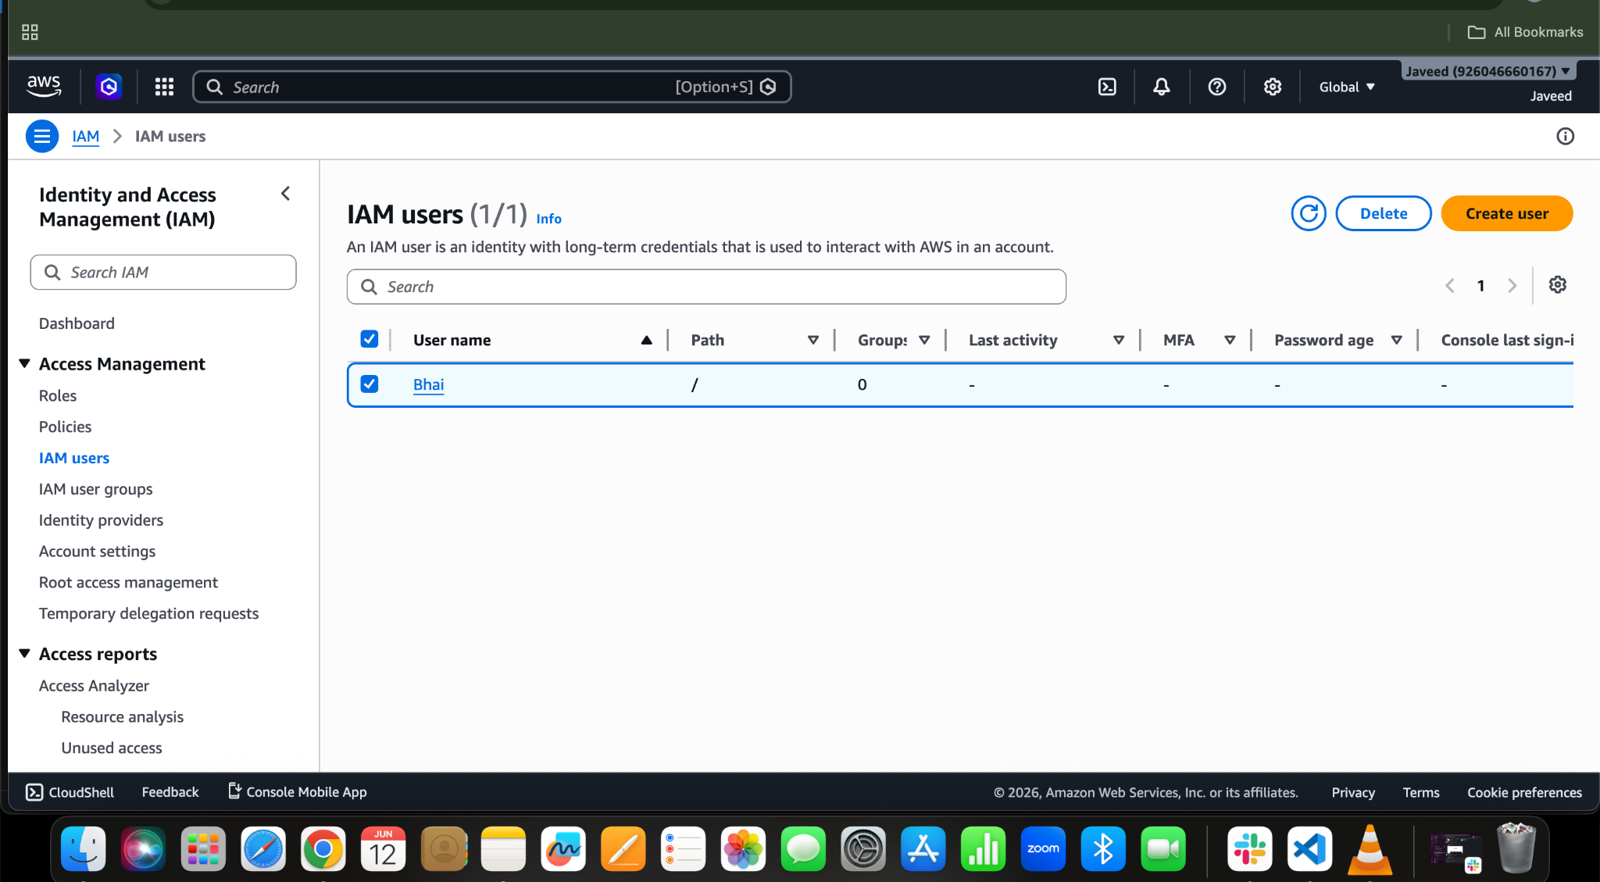

As we created user lets give him some permissions
resource "aws_iam_user" "Admin-user" {
name = "Bhai"
tags = {
"description" = "Technical Team Lead"
}
}
resource "aws_iam_policy" "Admin-user" {
name = "AdminUsers"
policy = file("admin-policy.json")
}

resource "aws_iam_user_policy_attachment" "Bhai-admin-access" {
user = aws_iam_user.Admin-user.name
policy_arn = aws_iam_policy.adminuser.arn
}

For giving him permissions lets write a policy
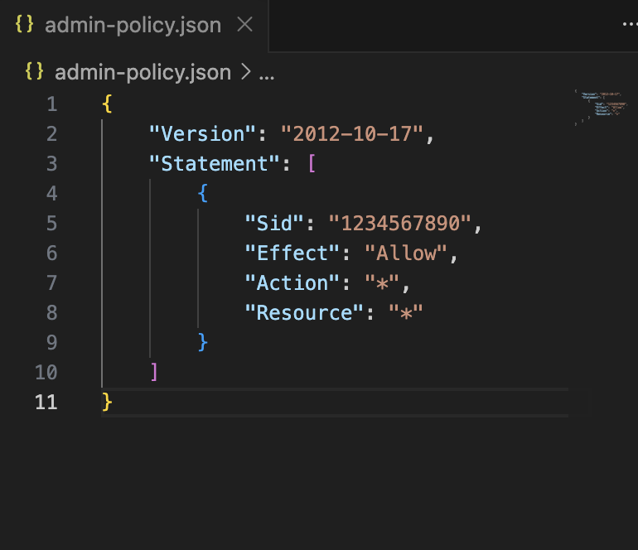

terraform apply
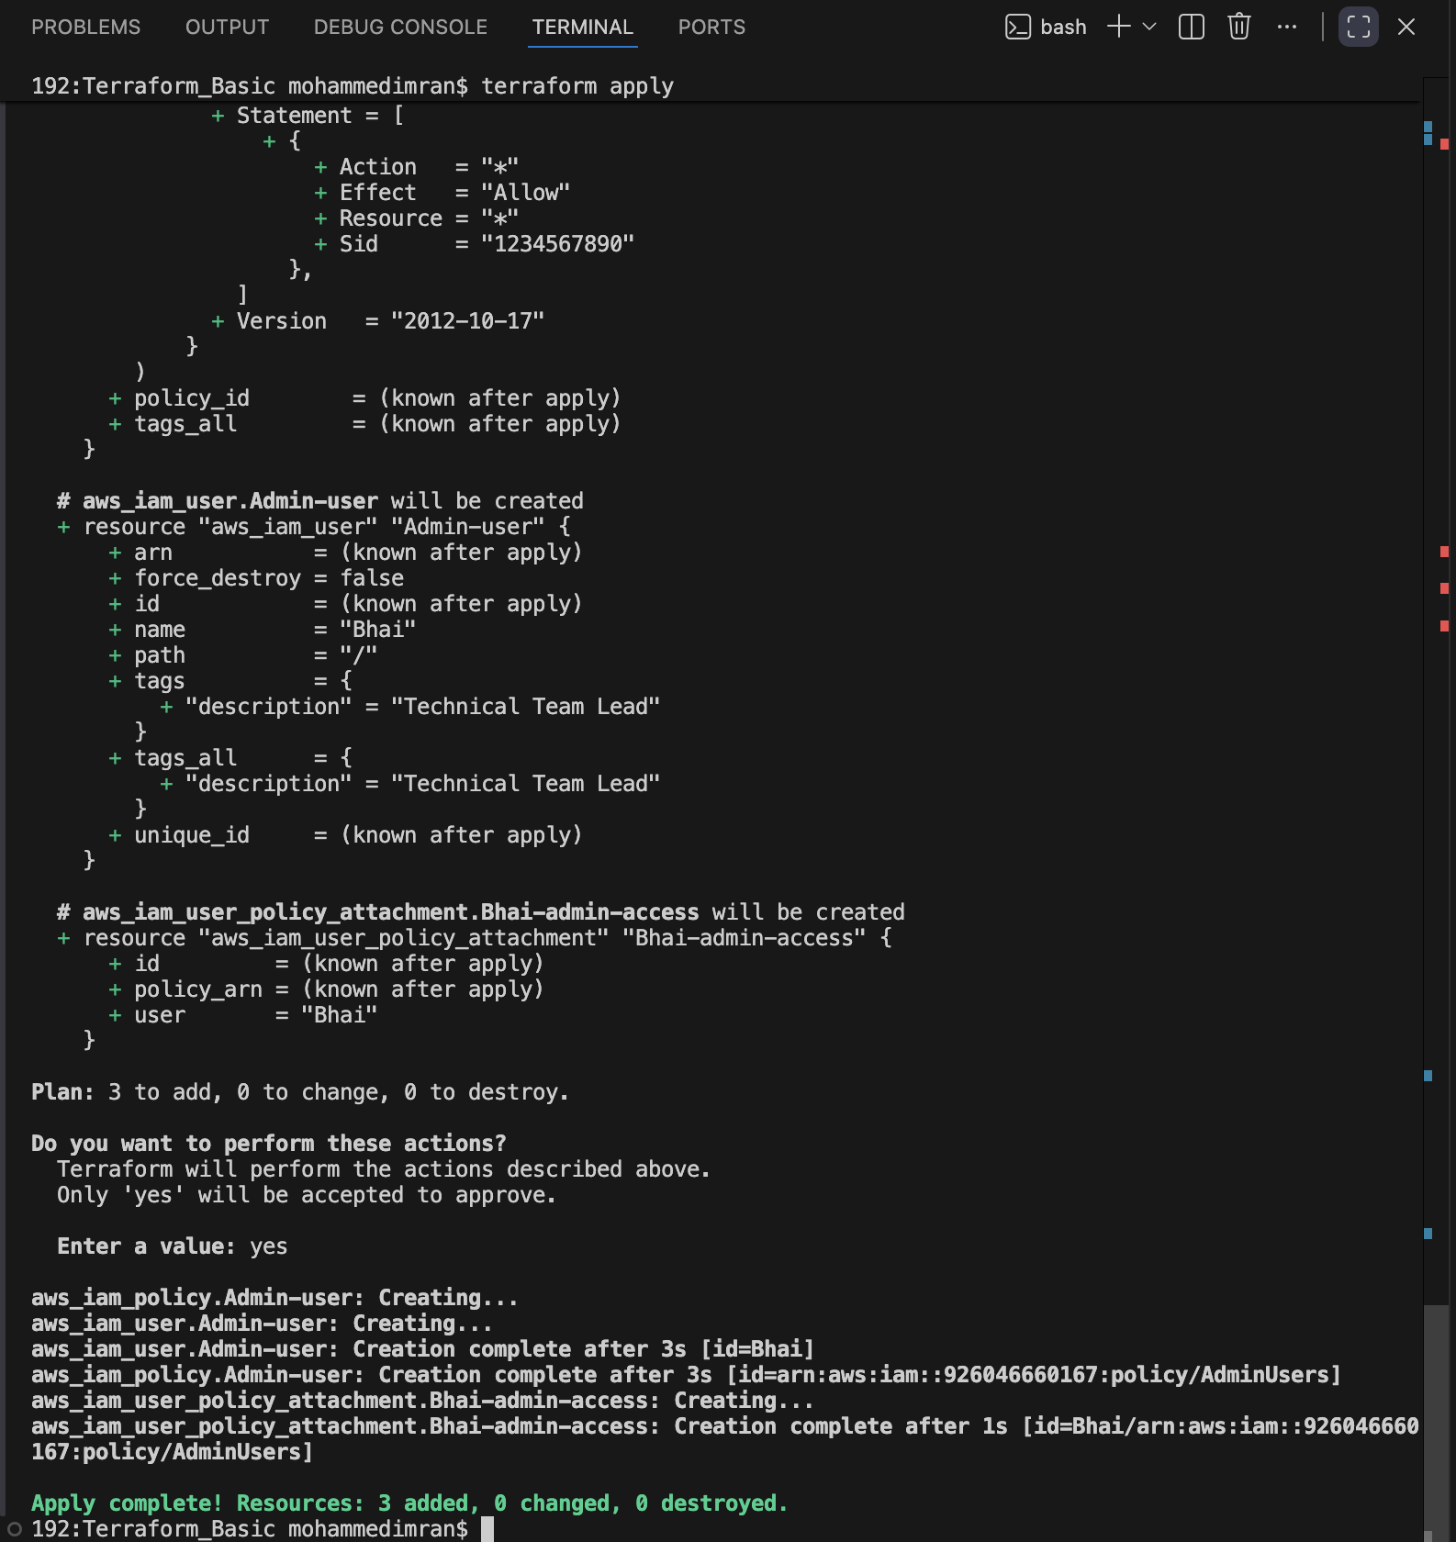
Lets see in AWS
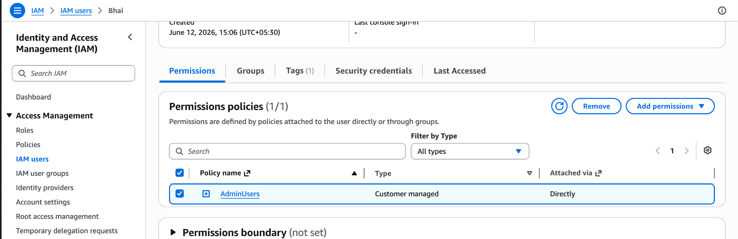
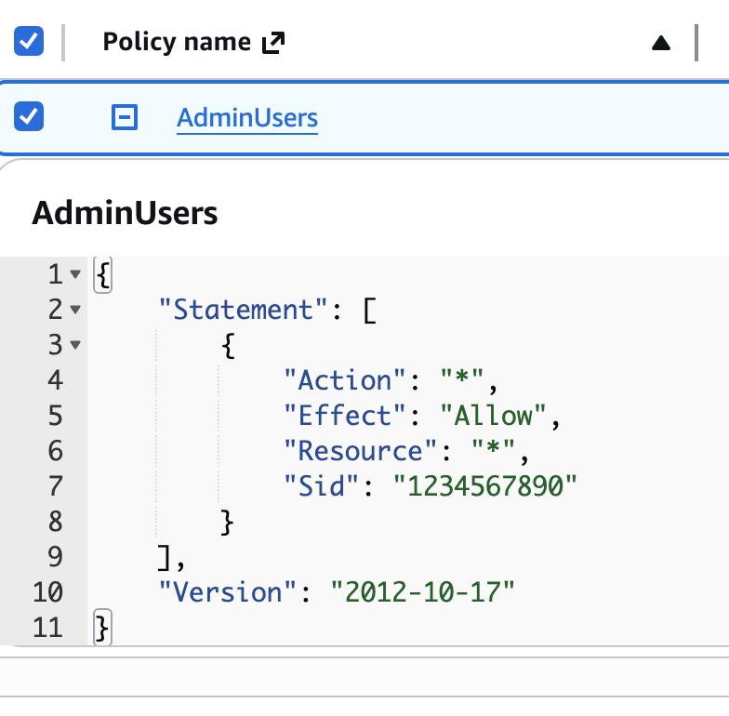

3). Integrate Terraform in Jenkins using the Terraform plugin.
Lets start Jenkins and Install the required Plugins
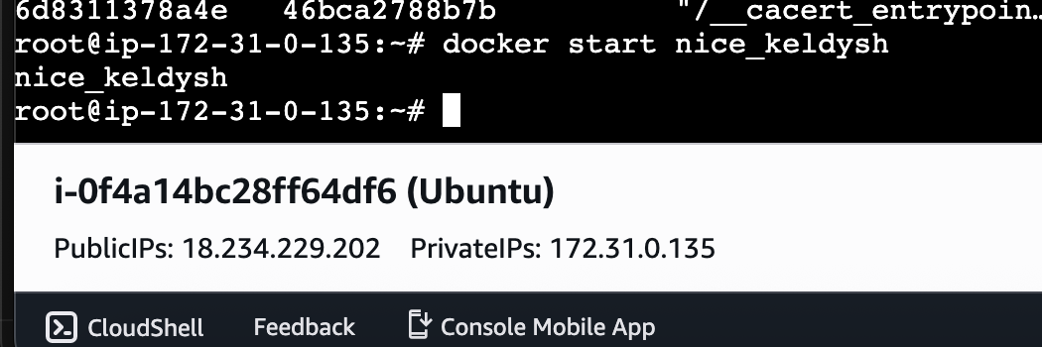
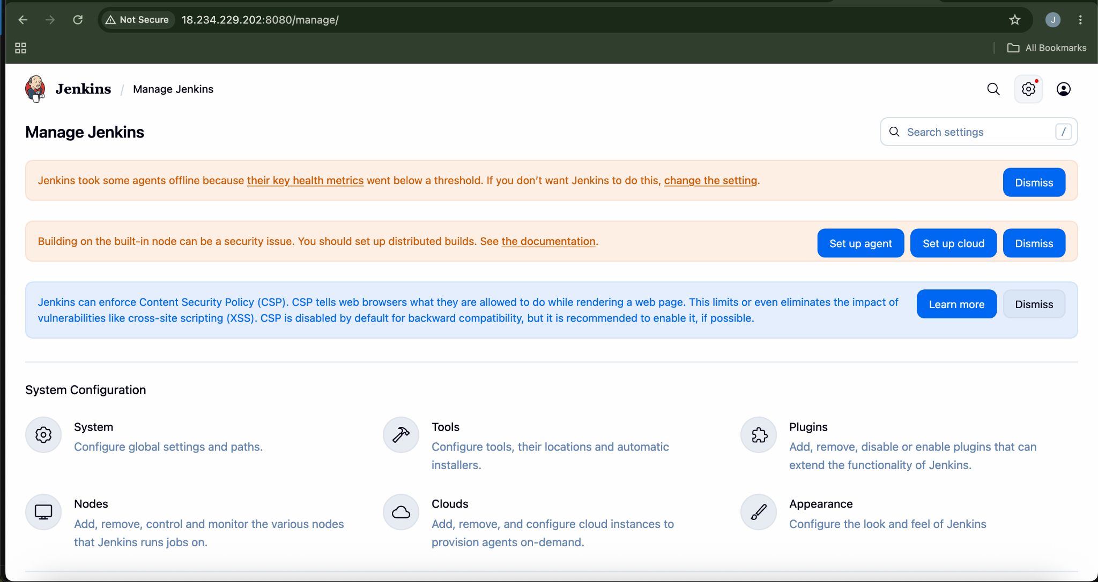
Install Plugin⇒terraform
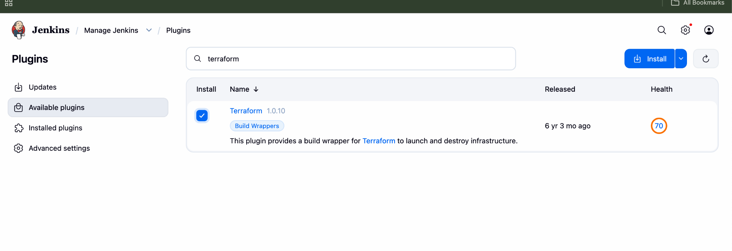
Plugin Installation Successfully
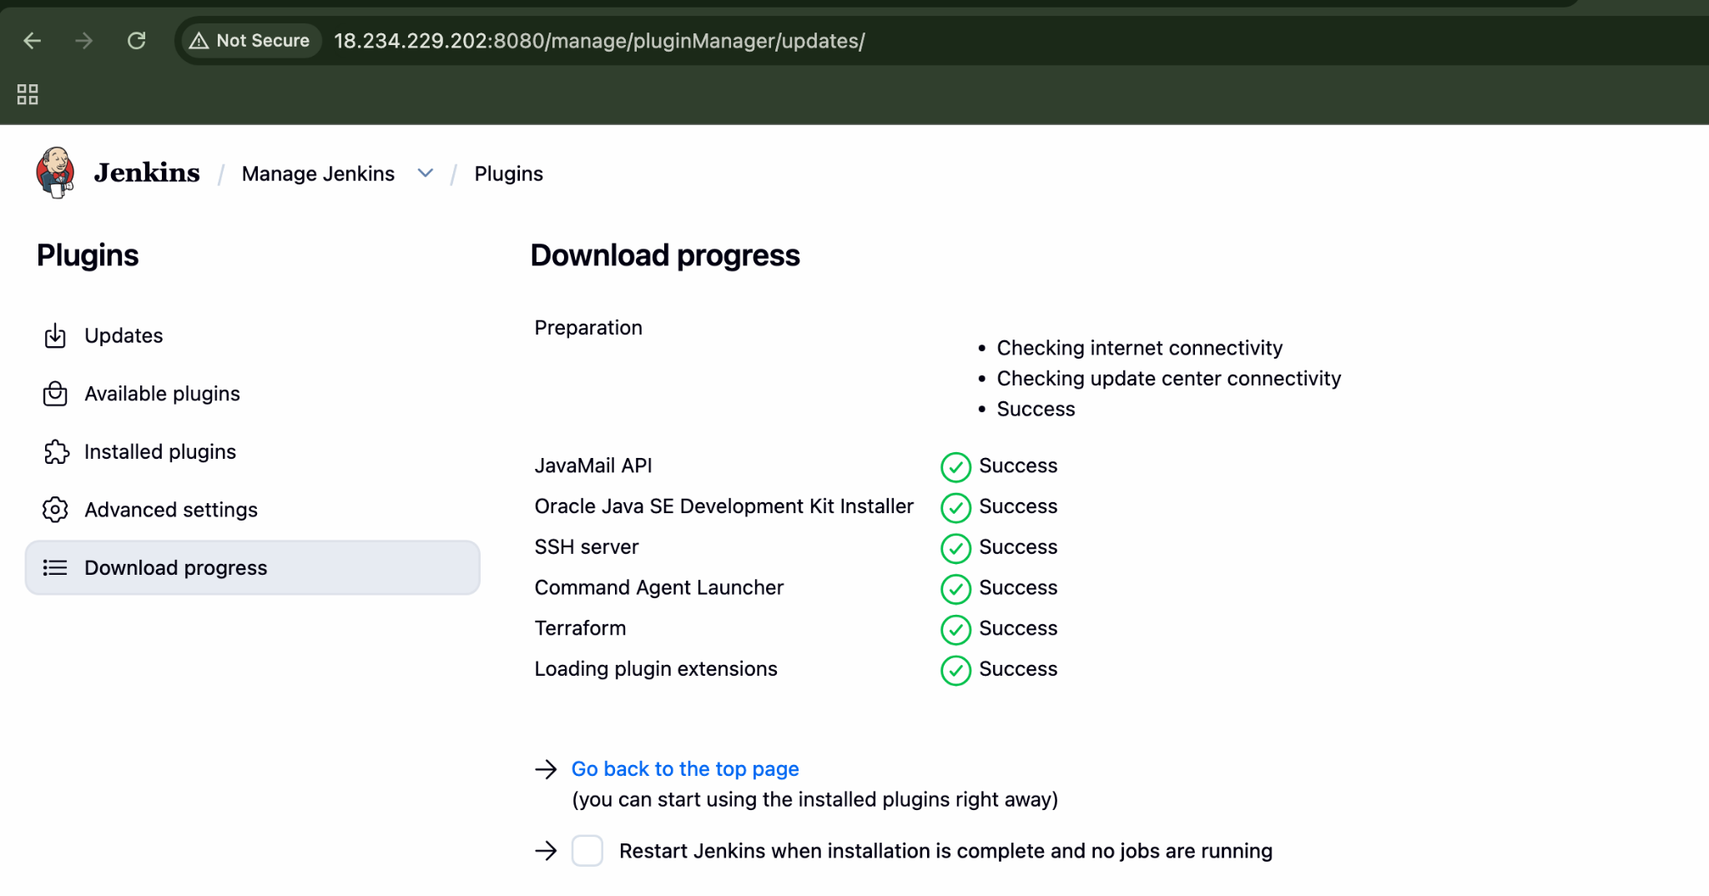
Now lets configure Terraform with Jenkins
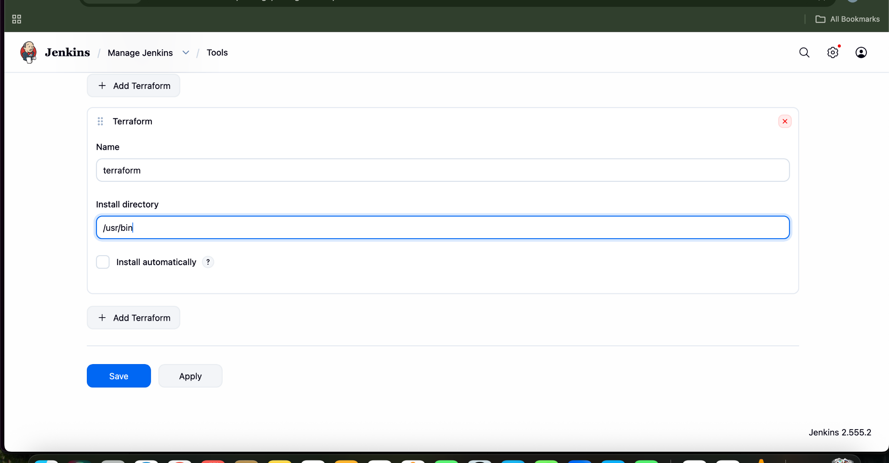

Now terraform has been configured
Now Lets create a main.tf
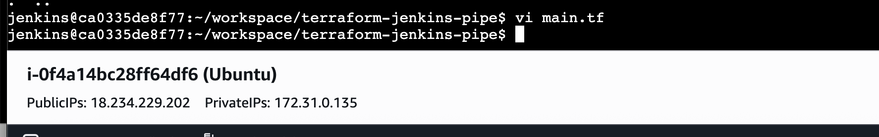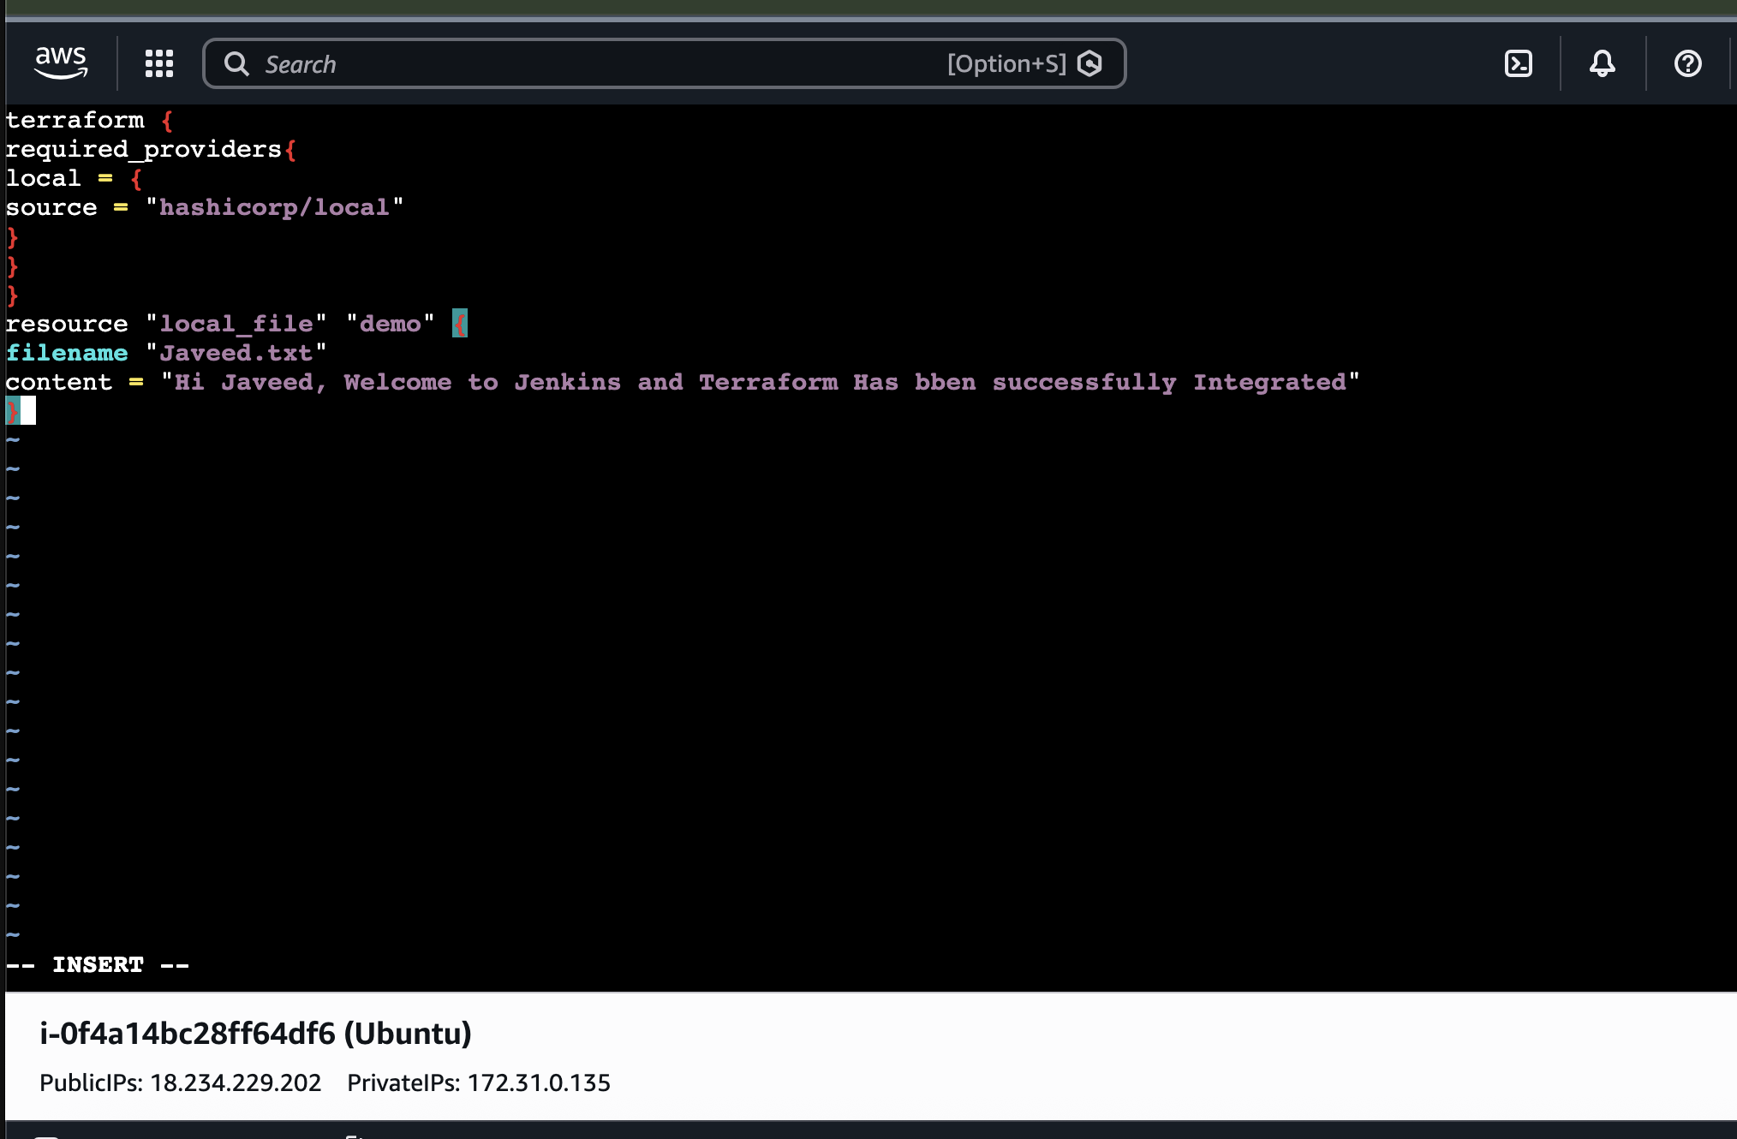
Create a test pipeline job.
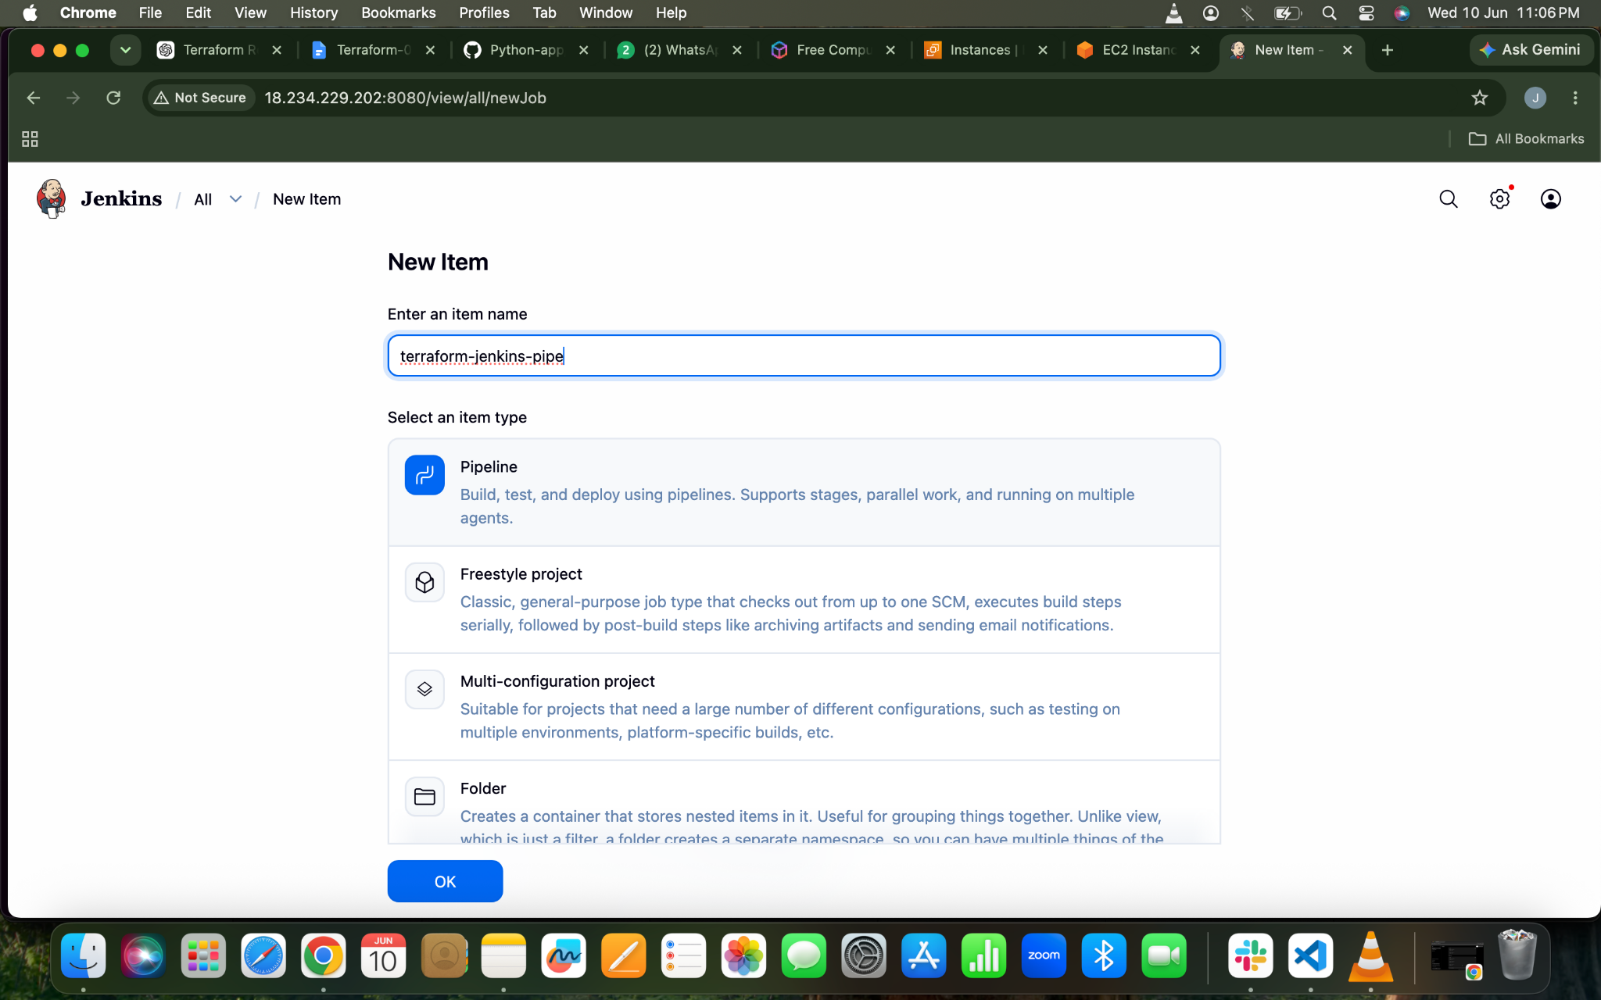
SCRIPT
pipeline {
agent any

tools {
terraform 'terraform'
}

stages {

stage('Check Terraform') {
steps {
sh 'terraform version'
}
}

stage('Terraform Init') {
steps {
sh 'terraform init'
}
}

stage('Terraform Plan') {
steps {
sh 'terraform plan'
}
}

stage('Terraform Apply') {
steps {
sh 'terraform apply -auto-approve'
}
}
}
}

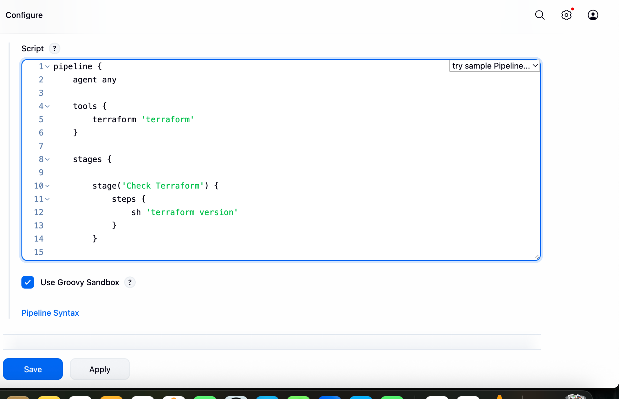

Lets Build The Job

Console Output
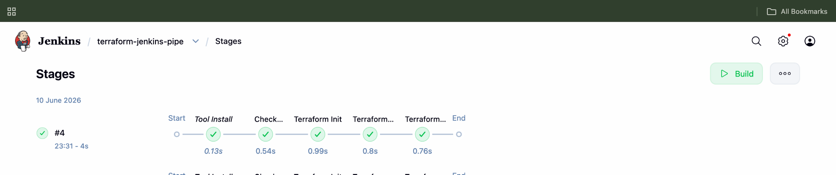
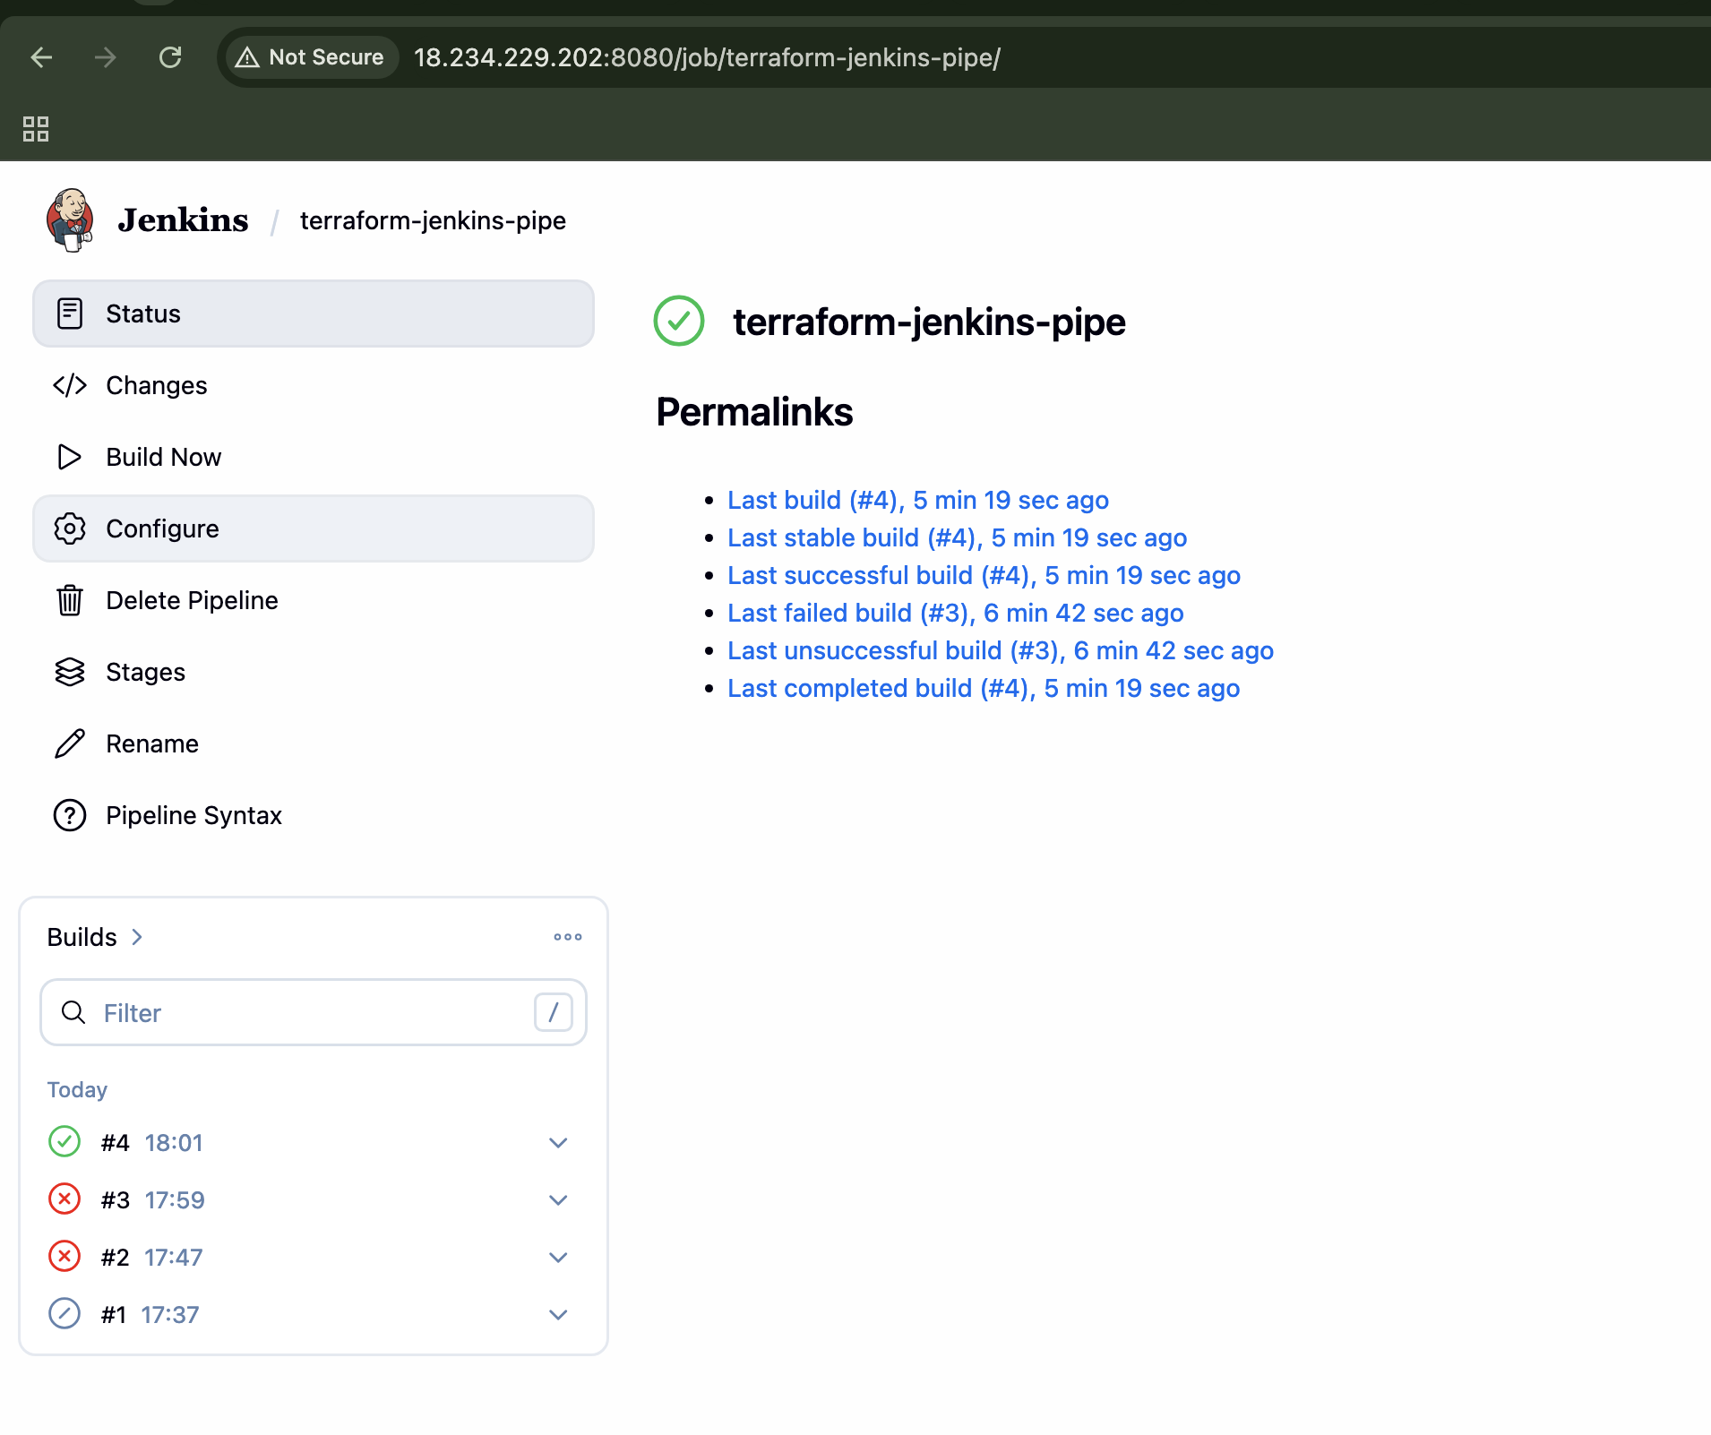
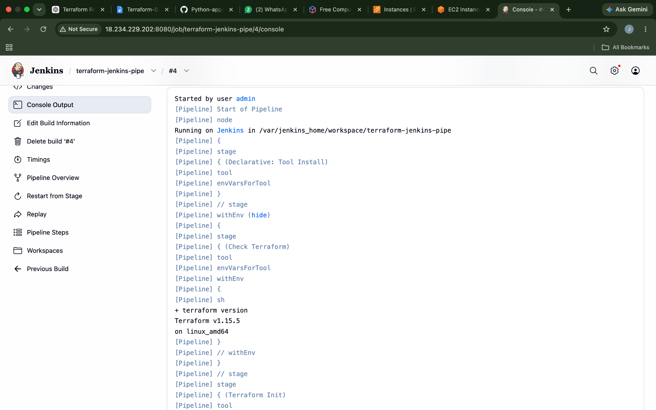

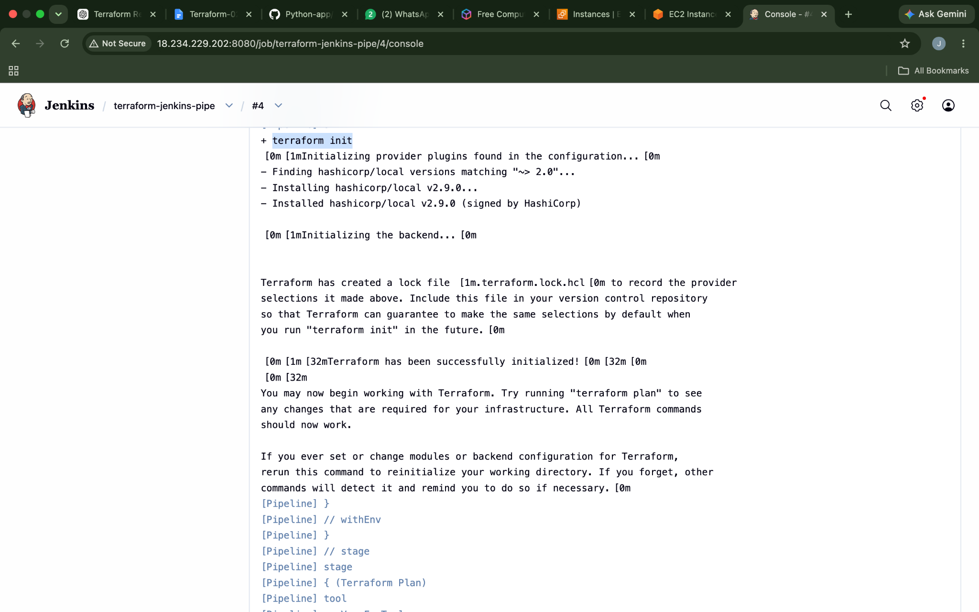
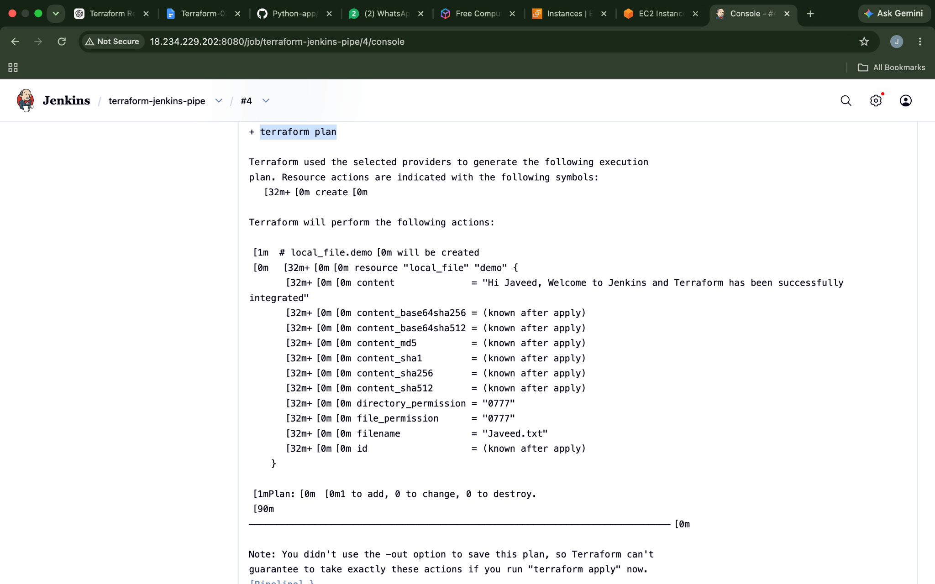
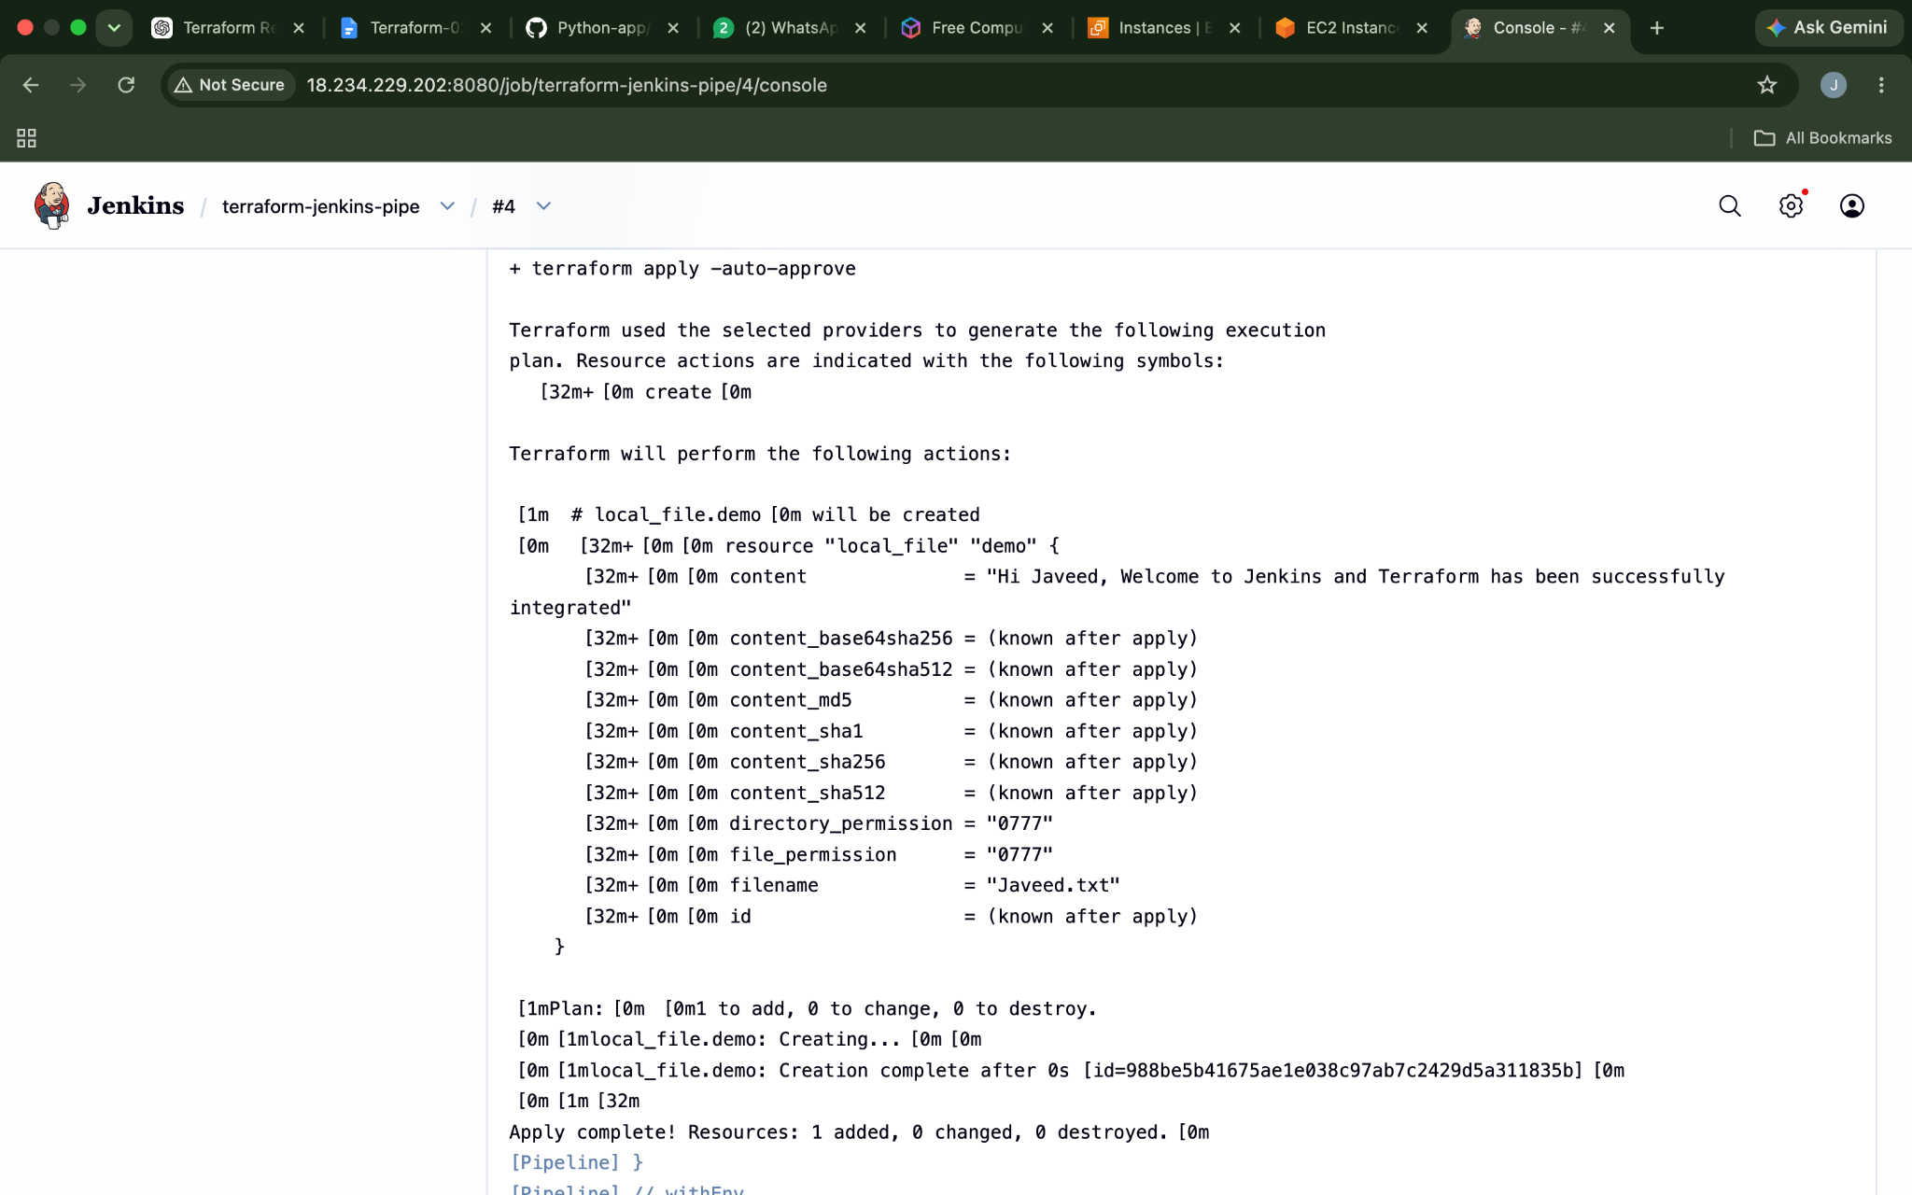
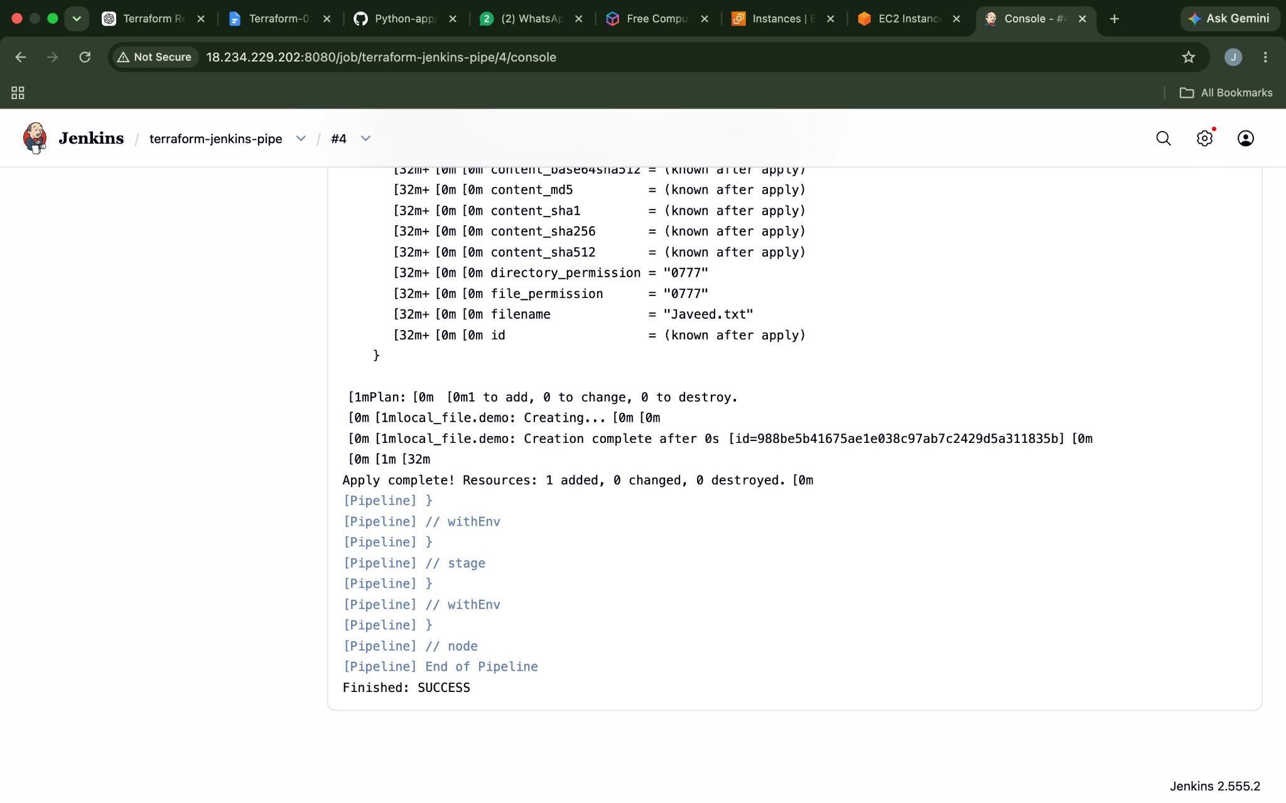
Now the folder has been created
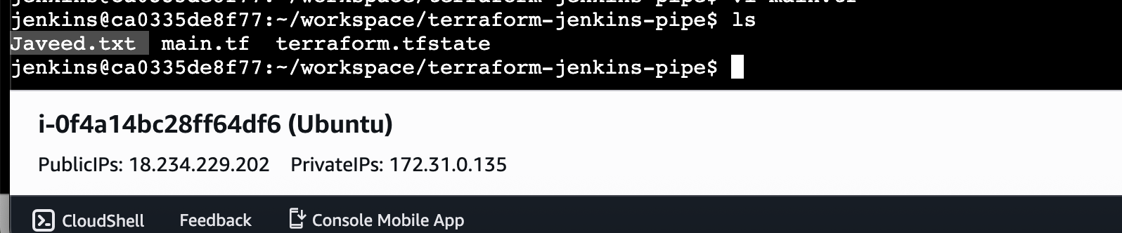

4). Create a CI/CD pipeline for a Nodejs Application: https://github.com/betawins/Trading-UI.git

Lets Install the pre-requisites in our machine first

apt update
apt install -y curl

curl -fsSL https://deb.nodesource.com/setup_20.x | bash -
apt install -y nodejs

npm install -g pm2

To Check the versions of what we have downloaded
node -v
npm -v
pm2 -v

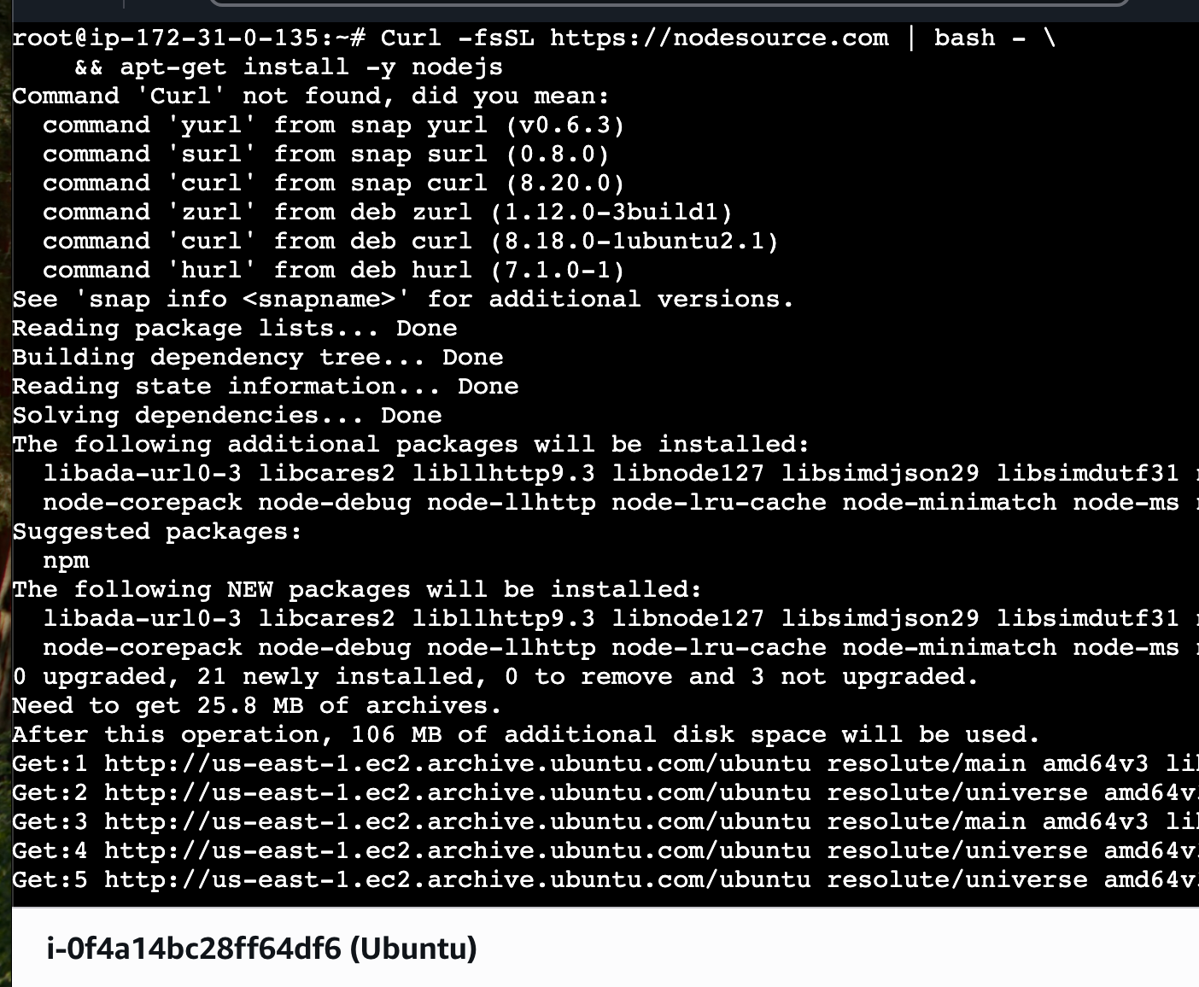

Lets start a pipeline job
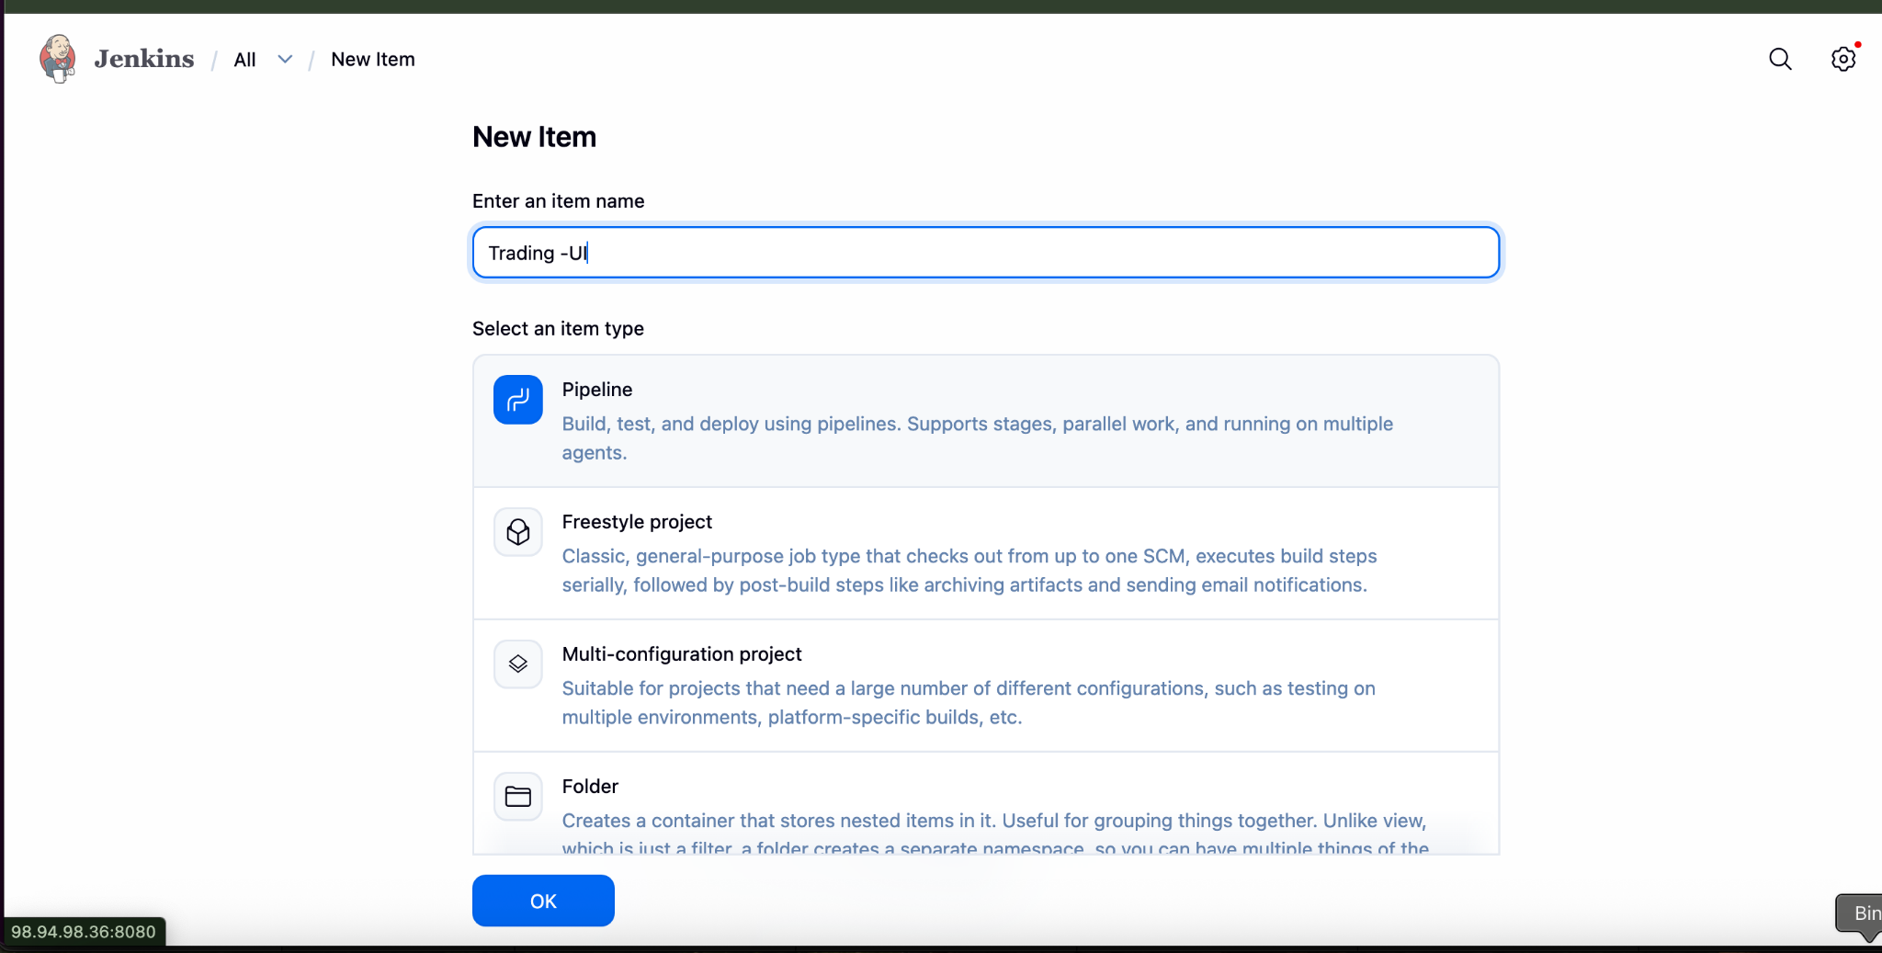

PipeLine
pipeline {
agent any

environment {
NODE_OPTIONS = "--openssl-legacy-provider"
CI = "false"
}

stages {

stage('Checkout') {
steps {
git 'https://github.com/betawins/Trading-UI.git'
}
}

stage('Install & Build') {
steps {
sh '''
npm install
npm run build
'''
}
}

stage('Deploy') {
steps {
sh '''
pm2 restart Trading-UI || pm2 start npm --name Trading-UI -- start
'''
}
}
}
}
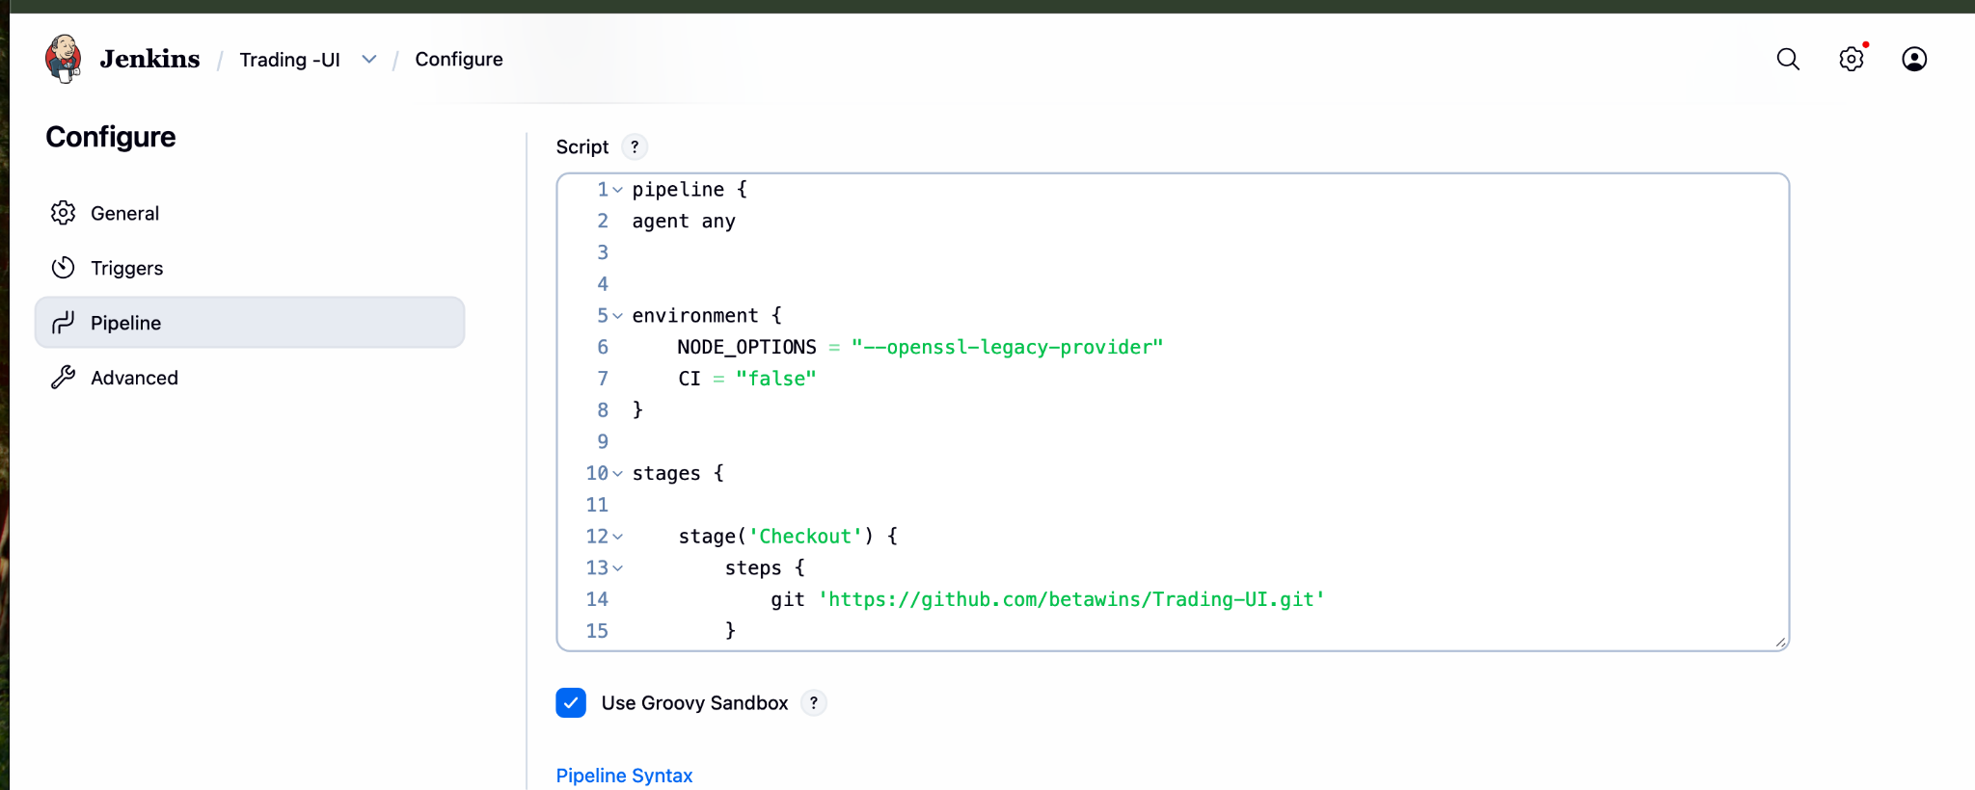
Lets Build the Job
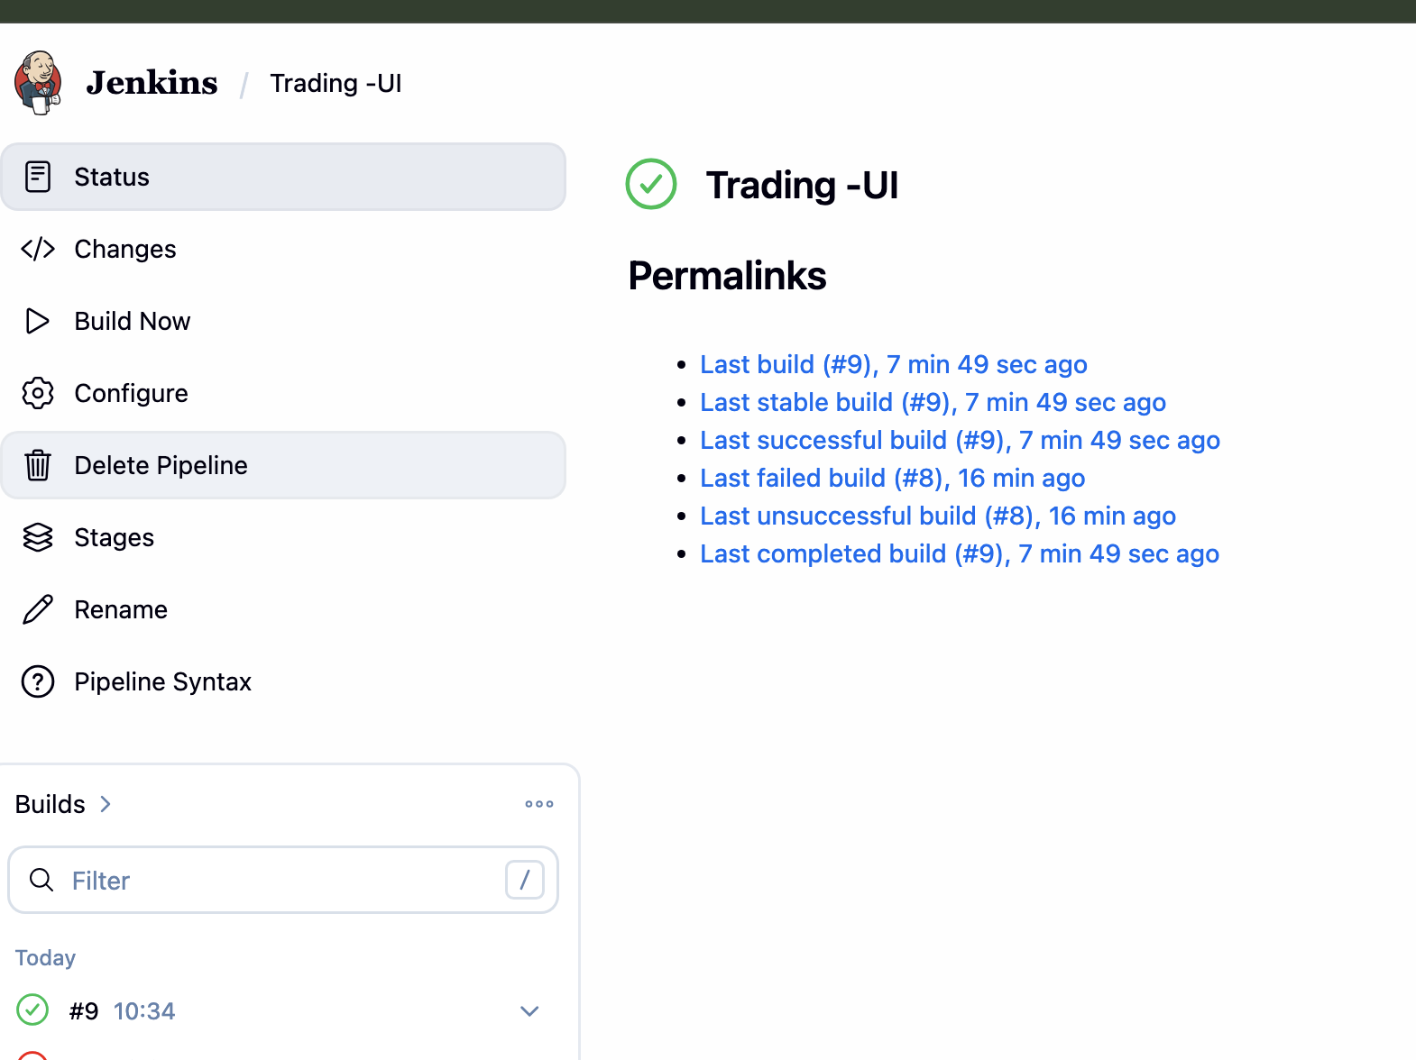
Console OutPut
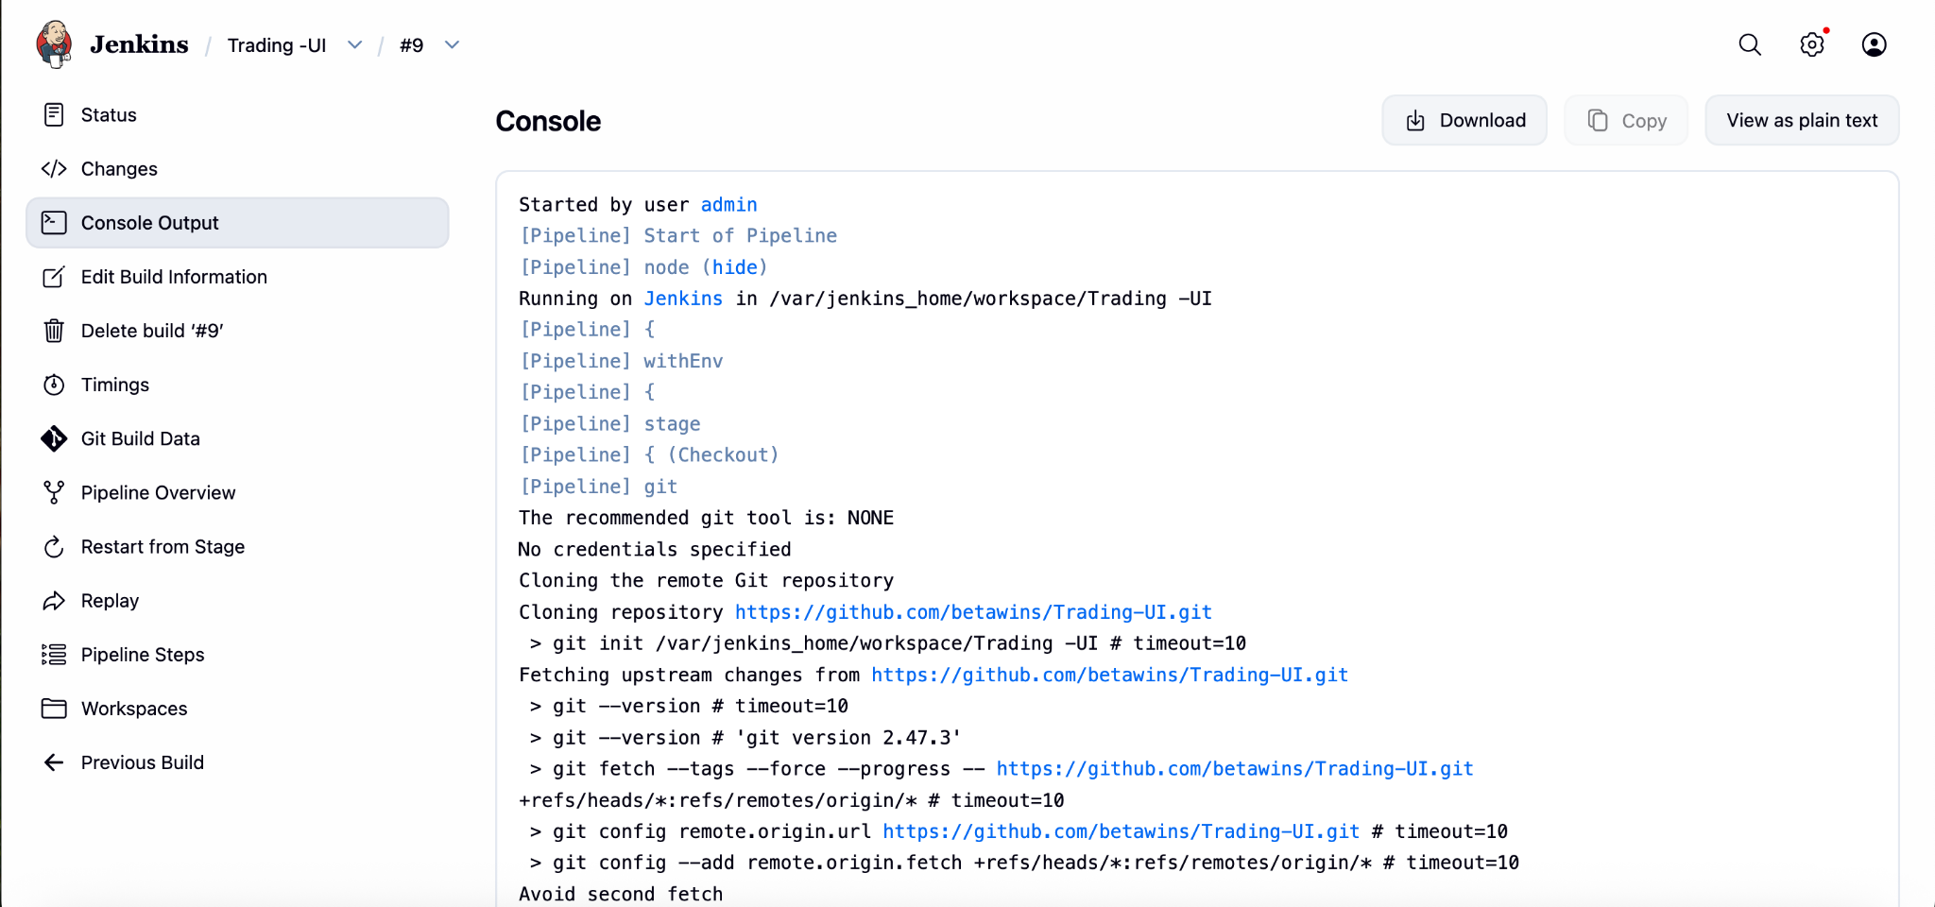
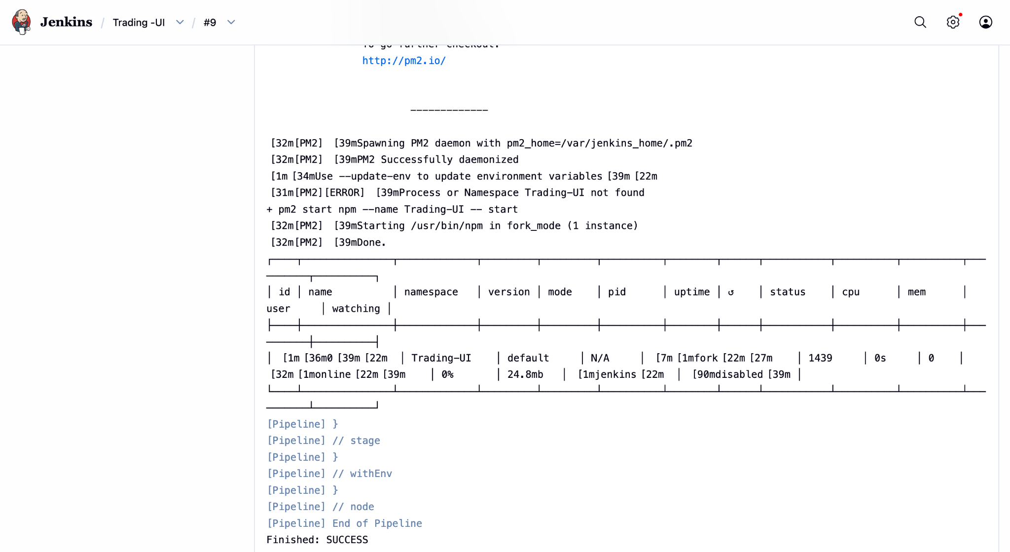

5). Explain 10 Maven commands.
Apache Maven is a popular Java build and dependency management tool. Its commands are run through the mvn CLI. Here are 10 important Maven commands and what they do:
1. mvn clean
Removes the target/ directory where compiled files and build outputs are stored. Useful to ensure a fresh build without old artifacts interfering.
2. mvn compile
Compiles the source code of your project (src/main/java). It does not run tests or package the application—only checks and compiles code.
3. mvn test
Runs unit tests defined in src/test/java using testing frameworks like JUnit. It compiles both main code and test code before execution.
4. mvn package
Takes compiled code and packages it into a distributable format like a JAR or WAR file inside the target/ directory.
5. mvn install
Installs the packaged artifact into your local Maven repository (~/.m2/repository) so it can be used as a dependency in other local projects.
6. mvn deploy
Copies the final package to a remote repository (like Nexus or Artifactory), making it available for other developers or CI/CD pipelines.
7. mvn validate
Checks whether the project structure and configuration are correct before the build starts. It ensures the project is ready to build.
8. mvn verify
Runs additional checks on the package after tests, such as integration tests or quality checks, to ensure the build is valid.
9. mvn dependency:tree
Displays the full dependency hierarchy of the project. Helpful for debugging version conflicts or unwanted transitive dependencies.
10. mvn archetype:generate
Creates a new Maven project from a template (archetype). It helps quickly scaffold standard project structures

